IOT BASED RESTAURANT INFORMATION SYSTEM

A Capstone Project

Presented to the Faculty of Instructions

College of Computer Studies

Carlos Hilado Memorial State University

Talisay City

In Partial Fulfilment

of the Requirements for the Degree

Bachelor of Science in Information Systems

By:

Baldago, Jehu Emmanuel U.

Coja, Juvelyn B.

Maquimot, Joshua N.

November 2023

Acknowledgement iii

# **ACKNOWLEDGMENT**

My sincere gratitude to my parents for providing my needs to help me finish this capstone project and for their full support of me and my group. Also, in this team, thank you for all your best and full-time cooperation. Lastly, to miss Jhelyn for her support and help with the codes that I cannot understand that she explained to me.

I want to express my deepest gratitude to my Almighty God, whose guidance and strength have inspired me throughout this journey. My heartfelt appreciation goes to my loving family for their unwavering support, encouragement, and understanding. I am immensely grateful to my close friends, who have been by my side, offering friendship, laughter, and a shoulder to lean on. To my cherished loved ones, your love and presence have been the driving force behind my endeavors. Special thanks also extend to my dedicated colleagues, whose collaboration, expertise, and camaraderie have enriched my personal and professional life. This achievement would not have been possible without the love and support of these special individuals in my life. Thank you from the bottom of my heart.

With sincere honor and gratitude, I am giving my utmost appreciation and thank you to everyone who accommodated me throughout this project. To our capstone adviser, Dr. Redoblo, to our Capstone instructor, Dr. Mondero, to our panels from when we began this endeavor until we finally accomplished this project, to my colleagues who have always supported our group in terms of developing our ideas, to my groupmates that never failed to amaze me in every step of this project development, and most especially, my sincerest gratitude goes to our almighty Lord. Despite all the sacrifices and circumstances, our creator ensured our team would overcome this journey with proudness and trust. Lastly, I want to mention my other sources of support whose names I’d like to keep myself. They may not know how I surpassed specialized tasks alone; however, this is my time to express how their music helped me to cope during the lowest and most challenging times.

Acknowledgement iv

Abstract v

# **ABSTRACT**

This study aimed to design and develop an IOT Based Restaurant Information System with the following features: sensor-based availability for cottages, point of sales, in-house QR code-based ordering, virtual queue for orders, menu listing, and sales and reservation monitoring. The developed system utilized descriptive and developmental methods with the use of a Prototyping developmental model. The system evaluation resulted in a total of fifteen (15) respondents, and a mean score of 1.8 is achieved with a remark of "Strongly Agree" using the PSSUQ questionnaire. An additional set of IT experts, with three (3) respondents, evaluated the system using the ISO 25010 (SQuaRE) evaluation tool. It achieved a mean score of 3.94 with a "Very Highly Acceptable" remark. A user manual is developed to guide end users on properly using the system and its functions. According to the gathered results, the system can help restaurant businesses enhance their work methods and let the customers enjoy the advancement of technology through ordering and reservations. The system is recommended to have more functions especially with the payment method to achieve a satisfactory and improved overall function.

Keywords: IOT, Restaurant, Reservation, Ordering, PSSUQ, ISO 25010 (SQUaRE)

**TABLE OF CONTENTS**

Table of Contents vi

Title Page………………………………………………………………………………………………. i

Approval Sheet………………………………………………………………………………………... ii

Acknowledgement……………………………………………………………………………………. iii

Abstract………………………………………………………………………………………………….v

Table of Contents…………………………………………………………………………………….. vi

List of Tables………………………………………………………………………………………… . viii

List of Figures…………………………………………………………………………………………. ix

**Chapter 1: Introduction**

* 1. Background of the Study…………………………………………………………………..….3
  2. Objectives of the Study………………………………………………………………………..4
  3. Scope and Limitations…………………………………………………………………………6
  4. Significance of the Study………………………………………………………………………7
  5. Definition of Terms……………………………………………………………………………..9

**Chapter 2: Review of Related Literature/Studies**

2.1 Foreign Literature or Study……………………………………………………………………12

2.2 Local Literature or Study……………………………………………………………………....16

2.3 Summary……………………………………………………………………………………….. 20

2.4 Synthesis………………………………………………………………………………………...22

**Chapter 3: Design and Methodology**

3.1 Systems Development Method………………………………………………………………..24

3.2 Operational Framework………………………………………………………………………..29

3.3 Context Diagram (Level 0)……………………………………………………………………..30

3.4 Data Flow Diagram (Level 1)…………………………………………………………………..31

3.5 Entity Relationship Diagram……………………………………………………………………32

3.6 Use Case Diagram……………………………………………………………………………...34

3.7 Data Dictionary………………………………………………………………………………….35

Table of Contents vii

3.8 Hardware and Software Requirements………………………………………………………38

3.9 Ghantt Chart…………………………………………………………………………………….40

3.10 System Usability and Reliability Testing……………………………………………………41

**Chapter 4: Results and Discussion**

4.1 Profile of Respondents………………………………………………………………………...44

4.2 Screen Prototype and Description……………………………………………………………45

4.3 System Testing Result…………………………………………………………………………53

4.4 Development of User Manual………………………………………………………………….61

**Chapter V: Summary, Findings, and Conclusion**

5.1 Summary of Findings……………………………………………….......................................62

5.2 Conclusion and Recommendation…………………………………………………………….63

**References**……………………………..……………………………………………………………….66

**Appendices**……………………………..……………………………………………………………....68

**LIST OF TABLES**

List of Tables viii

Table 1. Menu……………………………………………………………..…………………………. 36

Table 2. Pending………………………………………………………………..…………………… 36

Table 3. Table…………………………………………………………………………...…………… 36

Table 4. Orders………………………………………………………….…………………………… 36

Table 5. Sales………………………………………………………………………………………… 36

Table 6. Sales History……………………………………………………………………………….. 36

Table 7. Sensor IR…………………………………………………………………………………… 36

Table 8. Cottage……………………………………………………………………………………… 36

Table 9. Reserve……………………………………………………………………………………... 37

Table 10. Address……………………………………………………………………………………..37

Table 11. System Settings…………………………………………………………………………... 37

Table 12. Transactions………………………………………………………………………………. 38

Table 13. User………………………………………………………………………………………… 38

Table 14. Gantt Chart………………………………………………………………………………… 40

Table 15. Profile of the Respondents………………………………………………………………. 44

Table 16. Mean Scores in the ISO 25020 (SQuaRE) Evaluation ………………………….. …...53

Table 17. Mean Scores in the Usability Level……………………………………………………... 54

Table 18. PSSUQ – 3 Norms………………………………………………………………………... 55

Table 19. Mean Scores in the Usability as a Whole………………………………………………. 56

Table 20. Mean Scores in the System Usefulness………………………………………………... 58

Table 21. Mean Scores in Information Quality………………………………………………………59

Table 22. Mean Scores in Interface Quality…………………………………………………………60

**LIST OF FIGURES**

List of Figures ix

Figure 1. Prototyping Developmental Model………………………………………………………. 25

Figure 2. Operational Framework……………………………………………………………………29

Figure 3. Context Diagram………………………………………………………………………...… 30

Figure 4. Level 1 Data Flow Diagram………………………………………………………………. 31

Figure 5. Entity Relationship Diagram……………………………………………………………… 32

Figure 6. Use Case Diagram………………………………………………………………………... 34

Figure 7. Website Homepage……………………………………………………………………….. 46

Figure 8. Ordering Page for Customer……………………………………………………………….47

Figure 9. Cottage Reservation Page…………………………………………………………………48

Figure 10. Admin Dashboard………………………………………………………………………….49

Figure 11. Staff Dashboard……………………………………………………………………………50

Figure 12. Point of Sales………………………………………………………………………………51

Figure 13. Kitchen Staff Virtual Queue Page………………………………………………………..51

Figure 14. QR Code……………………………………………………………………………………52

**CHAPTER I**

**Introduction**

At this time, where technology is everywhere, innovations are widespread as aid for the difficulties experienced by various sectors. Issues do occur, especially in the management task. Given that conflict, specific problems are rampant in business operations. Thus, customer satisfaction is greatly affected. In today's time, when we go to a restaurant, we have to wait for a long time to place our order because there are already so many customers waiting to place their orders, and there are only a few servers present to note down the orders. Also, the same thing happens during delivery time. That is why one must wait long to receive the ordered item (Pandey et al., 2021).

Additionally, the customers experience frustration due to the underlying conflicts when booking reservations earlier. Also, the adequate portion of the operations could have been improved due to errors and unintentional mistakes. If one part of the process lags, other parts are also involved. Data management, data processing, and sales transaction processing still use manual systems with paper-based records that are open to risks in data management and data security. Another problem is that the cash register used to be working incorrectly, causing frequent human errors. Yet another problem in the management process was in reporting for sales and purchases, both daily and monthly, which was performed by manual data transfer, hence becoming the cause of ineffectiveness in time and reports preparation activity (Dewi, I., 2021).

The global arena of the Internet of Things (IoT) is massive and growing exponentially. Those in the emerging digital world have recently witnessed the proliferation and impact of IoT-enabled devices. The IoT has provided new opportunities in the technology arena while bringing several challenges to an increased concern. This research has both practical and theoretical impetus since IoT is still in its infancy, and yet it is considered by many as the most critical technology initiative of today (Nord et al., 2019). Being applied in the hospitality sector and management, the IOT Based Restaurant Information System aims to be a companion of the business in delivering excellent customer service.

Chapter I 2

**1.1 Background of the Study**

Chapter I 3

Restaurants are businesses that offer a variety of dishes, meals, and beverages. They are just distinct according to the services that they offer. Some restaurants are fine dining, casual dining, fast food, and even cafes. Nevertheless, the daily transactions of their business go up impressively due to the number of customers finding the perfect type of restaurant for them to dine in and take out meals. However, many restaurant businesses cannot deliver the best service due to the inconvenient manual and slow work flow. Since some restaurant businesses need more adequate staff, the tasks are piling up, especially during the peak hours when customers flood the restaurant premises to dine. A large number of transactions are done, monitoring the stocks needs to be accurate and timely, customer engagement and satisfaction, recording, and tracking of sales, all of these shall be done timely and effectively. Due to the large capacity of tasks under several components in the business, mistakes that lead to inaccuracies and conflicts occur.

MC Seafood Restaurant is one of the dining hotspots located in Silay City. Because of its well-known and unique cuisines and seafood menus, patriots from across the province drive their way to have a bite of the restaurant's limited dishes. Aside from the authentic menus they offer, they also cater to customers who love fishing through their fishpond, which is accessible to their area. During this time, when technology evolves its capacity to cover a broader scope of sectors, IOT in the hospitality and management field is likely to be successful. Many services are offered by IOT that do not only enclose their capacity inside of institutions but also outside of their area. Most commonly used, like ordering and delivering apps for reservations and RFID to pay transactions, are much more common these days.

Chapter I 4

Specifically, a Restaurant Information System can improve operations by deducting the time of ordering and payment without removing the service of the workforce. By utilizing the system, restaurant businesses can enhance their daily operations as the automated methods will rapidly accomplish many tasks. The system will introduce computerized ways of doing tasks. The business status is also monitored effectively if a systemized approach enters the business environment. Their customers will utilize a new ordering system inside and outside of the restaurant premises to experience efficiency while dining. The cottage reservations are also improved as sensors with the help of IOT are used to monitor the availability of cottages for online booking reservations. Furthermore, the system can help leverage developments on the parts that businesses do not mainly focus on.

**1.2 Objectives of the Study**

The purpose of this study was to develop an IOT Based Restaurant Information System.

Specifically, this study aimed to:

1. Design and develop IOT Based Restaurant Information System the following technical features:

1. sensor-based availability for cottage;
2. point of sales;
3. in-house QR code-based ordering;

Chapter I 5

1. virtual queue for orders;
2. menu listing and;
3. sales and reservation monitoring.

2. Test the functionality of aforementioned features using the ISO 25010 (SQuaRE) evaluation tool for system design and development for experts in terms of:

1. functional suitability;
2. performance efficiency;
3. compatibility;
4. usability;
5. reliability;
6. security;
7. maintainability and;
8. portability.

3. Test the usability of the system by end-users in terms of:

1. system usefulness;
2. information quality;
3. interface quality and;
4. overall usability.

4. Develop the user’s manual of the system.

**1.3 Scope and Limitation**

Chapter I 6

This project focuses on the development of a Restaurant Information System. The system's primary goal is to aid restaurant businesses with their operations effectively and wisely. The point-of-sales system can only accept cash payments; a receipt is generated after every transaction. The mobile-phone-based in-house ordering support allows the customers to perform the direct and automated ordering method after scanning a QR code. The customers can browse the meals, place their orders, enter notes for their orders, and use the cash-based payment method. The system shows a glimpse of how the cottages of the restaurant look before the customers reserve a specific cottage through online booking. The customers know the availability of the cottages that are monitored by sensors with the help of IOT through a red and green color scheme.

The PIR sensor can detect up to five (5) meters of movement away from the sensor. The kitchen staff also have their screen where they can see the virtual queue for the orders placed by customers and the cashier. Lastly, the administrator system holds all the history of records made by the users of the point of sales system, in-house online ordering support, and cottage reservations. The status of the business sales and history of transactions are tracked. The administrator can also create specific user credentials and accounts for every user assigned to use the point of sales system.

The system is available only for restaurant businesses, employees, and valued customers. The point of sale is available for personal computers, laptops, and tablet devices. The ordering system is available for smartphones, and the virtual queue interface is accessed using a tablet. The system should be connected to Wi-Fi as data are exchanged in real-time. The system will not work without the presence of Wi-Fi. The features of the system include the following: sensor-based availability for the cottage, point of sales, in-house QR code-based ordering, virtual queue for orders, menu listing, and sales and reservation monitoring.

Chapter I 7

**1.4 Significance of the Study**

The study was beneficial to the following stakeholders:

***Customers.*** This study allows customers to experience automated and seamless

transactions. The customers can efficiently manage the time they spend on ordering and paying as this study offers an online ordering system to place orders inside or outside restaurant premises and utilize an online method for faster menu and table reservations.

***Servers.*** This study aids the restaurant servers in completing their tasks

effectively. The servers were able to increase their productivity in terms of other tasks aside from taking orders, as most of the orders were completed and submitted by customers without servers needing to approach the customers personally at their tables. This study improves the work process that needs to be done by the staff members and helps them deliver quality service to their customers.

***Cashier***. This study allows the cashier to do multiple tasks while guarding the

cashier area. The process of inputting orders are done faster as the cashier is able to increase the accuracy rate of dealing with orders. The cashier can ensure that the sales made each day have an accurate record to avoid conflicts and inaccuracies in keeping track of the sales and profit.

Chapter I 8

***Kitchen Staff*.** The study is beneficial for the staff inside the kitchen premises of

the restaurant as it will integrate a user interface that will show the orders and improve their technique to do their tasks and serve meals. This study allows them to experience a seamless flow of queuing in terms of customer meal orders.

***Owner of the Restaurant.*** This study benefits the owner by improving the

management of the business. The owner can effectively monitor the business's status, including improving their processes. The owner can assess if the business is profiting well. By this study, the owner can effectively keep track of the sales, resulting in a better assessment and avoiding conflicts and manipulation in sales and inventory management.

***Researchers.*** This study allows the researchers to enhance their skills in system

development. This study helps the researchers analyze existing difficulties and contribute a solution to improve a process or create positive outputs. This study adds to the researchers' expertise and improves how they contribute action plans to implement the lessons they learned while taking the curriculum aligned to this study.

***Future Researchers.*** This study will serve as a reference for gathering information

for future researchers who wish to pursue research related to the study.

Chapter I 9

**1.5Definition of Terms**

The researchers defined the following terms operationally to understand the study better.

**Compatibility** – It is defined in this study as the overall system's ability to

exchange information between hardware and software devices.

**Functional Suitability** – It is defined in this study as the system providing

functions that meet the stated objectives.

**In-house Online Ordering** – It is defined in this study as the method of purchasing

menu items inside the restaurant premises with the use of devices, specifically mobile devices and having the ability to pay through the cash payment method.

**Information Quality** –It is defined in this study as the degree to which the

information provided by the IOT Based Restaurant Information System is easy to interpret and use by the end users.

**Interface Quality** –It is defined in this study as the degree to which the interface

of IOT Based Restaurant Information System is easy to locate and understand by end users.

**IOT Based** – It is defined in this study as the method of a platform where users

can exchange data through devices such as personal computers and mobile devices with the help of hardware devices such as sensors to gather data.

**Maintainability** – It is defined in this study as the overall system is well even after modifications.

Chapter I 10

**Menu Item Listing** –It is defined in this study as a process of recording menu

items. The lists vary according to the menu's I.D., name, price, and category.

**Monitoring** – It is defined in this study as the process of checking and assessing

the status of the business components. Monitoring is used to ensure that the flow of the business is still at its best and to identify risks to provide mitigation methods and solutions.

**Online Reservation** – It is defined in this study as the method of securing items

or services to be used on a specific date and time.

**Overall Usability** –It is defined in this study as the degree to which the overall

technical features of the IOT Based Restaurant Information System are easy to use and evaluate by the end users.

**Performance Efficiency** – It is defined in this study as the overall performance

relative to given resources used in stated conditions.

**Point Of Sales** –It is defined in this study as a system used to record sales, orders,

or transactions usually present in businesses.

**Portability** ­– It is defined in this study as the overall system is well even after being

transferred to different environments.

**QR Code-Based Ordering** – It is defined in this study as a unique code utilized

by users to enter a specific site, connect to a network, and purchase products online.

**Reliability** – It is defined in this study as the system's overall performance is well

under specific conditions.

Chapter I 11

**Restaurant Information System** – It is defined in this study as a system

empowered by technology used by restaurant businesses to improve their transactions, monitor their operations and sales, produce quality service for their consumers and employees, and leverage positive effects and profit.

**Sales Monitoring** – It is defined in this study as the process of monitoring the

sales made by a business in a specific timeframe. It allows especially owners to determine if the business is profiting or losing money and resources.

**Security** – It is defined in this study as the information the system provides is far

from vulnerabilities.

**Sensor-Based Reservation** –It is defined in this study as the use of an IOT

device, such as a sensor, to detect movements and determine the availability of cottages by identifying if it is in use or available.

**User’s Manual** – It is defined in this study as the step-by-step guide for end users

on how to properly use and locate the interface pages and information provided by the Based Restaurant Information System.

**Usability** – It is defined in this study as the overall system is effective and efficient

to use.

**Virtual Queue for Orders** – It is defined in this study as the interface with the

use of a device such as a tablet to show and present the current view of orders made by customers.

**CHAPTER II**

**Review of Related Literature/Studies**

This chapter contains the selected review of related literature, studies, and the interrelated system as proponents' basis for making and developing the IOT Based Restaurant Information System.

**2.1 Foreign Literature or Study**

**A Review of Building Occupancy Measurement Systems**

Information about the human dimension is essential for effective building energy conservation, productivity and health, comfortable surroundings, and security management. Numerous studies have been created to measure occupancy information. However, the coverage of new images/video-based methods in existing review work is limited. This paper reviews various sensor occupancy measurement systems, focusing on methods based on photos and videos. This study thoroughly analyzes various camera types (depth or non-depth) and installed locations (interior or room entrance). The researchers classify these studies and evaluate their consequences based on the information provided by the motion and static image data. This paper analyzes and discusses the applicability, limitations, and other sensors, such as electricity meters, carbon dioxide (CO2)

sensors, wireless fidelity (Wi-Fi), and passive infrared (PIR) sensors. Since various sensors can compensate for one another, sensor fusion techniques typically yield better results. Future trends, such as cloud computing platforms, artificial intelligence (deep learning technologies), and the fifth-generation mobile network (5 G), are also discussed (Sun et al., 2020).

Chapter II 13

**Online Engagement Among Restaurant Customers: The Importance of Enhancing Flow for Social Media Users**

A significant component of the contemporary guest experience in the hospitality sector is now online engagement, thanks to the growing use of digital communication technologies. The flow theory is especially crucial for understanding customer engagement in an online setting. This research examines the flow's precursors and its impact on users' positive attitudes and intentions to continue using social media. As flow results in positive attitudes and intentions to continue, the study's findings demonstrate the importance of flow in increasing customer engagement. Specifically, flow is significantly influenced by challenge, information quality, and system quality. This study strengthens the field by contributing to the limited scholarly literature on customer engagement and flow experience in the hospitality context. Furthermore, it offers valuable advice on gaining an edge over competitors by strategically controlling customer interaction through social media marketing flow (Kim et al., 2020).

**IOT Based Restaurant Automation System**

Chapter II 14

The Internet of Things is referred to as IOT. The IOT platform is popular right now in the IT industry. The Internet of Things (IoT) is a contemporary perspective contemporary perspective on the world that will contribute to its digitization. IOT represents the lines separating the real and digital domains. The Internet of Things is now prepared to provide a platform enabling physical objects to become smart devices and offer intelligent services. Everything in the Internet of Things, including sensors and smart devices. Possess a unique identity. Together, they create the communication network and become objects actively participating. Monitoring, tracking, and counting all IOT devices can significantly reduce waste, loss, and expense. The IOT will introduce numerous new applications in the future. These days, the manual food ordering method is used by many restaurants worldwide. Customers place orders using a server using a pen and paper in this food ordering system. In reality, the system needs more workers to handle customer inquiries, meal orders, and order placements in the restaurant system. One way to save time is to use this method. In a restaurant setting where multiple patrons are arriving at once, it is feasible for orders to be switched. It results in miscommunication between the client and the server and adds to the cashier's workload by requiring them to document the entire transaction. The project's objective is to automate the billing and meal ordering systems (Nandre et al., 2019).

**Designing Web-Based Food Ordering Information System in Restaurant**

Chapter II 15

They are assessing the level of customer satisfaction and service quality in the meal service system. Ali and Beg characterize the web as a collection of dynamic, varied documents that, in their development, integrate human intelligence, data filtering, information search, instruction, and providing suitable user needs that are addressed in various fields. According to Odhiambo, the customer is the foundation of the business's growth. Hence, maintaining sales growth requires the presence of a driver that keeps customers coming in. Maind's study on the Ordering System Room demonstrates that using a smartphone or tablet to place an order can help restaurants avoid ordering errors and improve their accuracy and efficiency in time for service requests. The food industry is constantly changing to follow trends, and food businesses' service systems must also adapt to their customers' lifestyles. One way to do this is by introducing technology-based service systems, as research from Maind explains in support of this study. The findings of research by Boo, Shariff, and Yii revealed that, in the food industry, service is another factor that determines customer loyalty and satisfaction in addition to price and food quality (Warlina & Noersidik, 2018).

**Foody – Smart Restaurant Management and Ordering System**

Restaurants pay close attention to what patrons say about their service because it affects the company's reputation. Maintaining a high service standard and delivering the services efficiently to reduce consumption time are critical components of assessing customer satisfaction. When choosing a well-known restaurant, patrons typically consider their favorite dish in addition to the seating and space options offered. Every restaurant makes the same mistakes that eventually drive away customers: long wait times and serving the wrong order. By giving each customer a personalized menu that considers their tastes, the "Foody" online application seeks to solve these shortcomings and offer accurate and efficient services to the user. This includes visuals and three-dimensional modeling that give physical details about food, like hues and sizes. In addition, the user can see the meal's ingredients and the available tables. The app also displays a real- time map with the restaurant's location. The table's color changes to reflect the status of the current reservation. The system calculates the wait time and provides a personalized meal recommendation and order for each customer based on an analysis of their social media activity. The research's anticipated result is creating a fully automated restaurant management system with the features above (Liyanage et al., 2018)

Chapter II 16

**2.2 Local Literature or Study**

**Predictors Of Customer Satisfaction and Behavioral Intention of Themed Restaurants in Manila, Philippines**

Over the past few decades, there has been a notable increase in the restaurant industry's growth. Customers' expectations are rising steadily from a more entertaining setting to a complete dining experience. Due to this increased demand, creative restaurant concepts that combine fresh entertainment with food and beverage service have emerged. The "themed restaurant industry" got its start with the emergence of various restaurant concepts and themes. A precise definition of a theme restaurant has yet to be determined. The literature thus proposes a definition based on earlier research: theme restaurants were created to offer patrons an enjoyable dining experience in addition to a meal. The impact of the five dining experience dimensions that patrons evaluated on behavioral intention and disconfirmation in themed restaurants was investigated in this study and through a mediating role of disconfirmation pleasure response, evaluated the excellent effects of the proposed model and the relationship between the food, service, physical environment, price fairness, and social interaction of the experiential dining dimensions and customer satisfaction and loyalty. This study demonstrated that experiential dining food quality, service quality, physical environment, fair pricing, and social interaction significantly affect patrons' overall experience. This study contributed significantly. (Masa J.R., 2021).

Chapter II 17

**Perception of Stakeholders on the Adoption of 4th Industrial Revolution Technologies in the Hospitality Industry in the Philippines**

The hospitality industry is experiencing paradigm shifts due to recent technological advancements. This is known as the "4th industrial revolution" (4IR), which focuses on adopting technologies such as IoT, which have led to exponential changes in how we live, work, and interact with one another. This study used a qualitative approach to investigate how stakeholders, specifically government agencies, industry practitioners, and academic institutions, perceived the changes brought about by the 4IR and how the hospitality sector in the Philippines responded to them. Results demonstrated the critical role technology plays in the Philippine hotel sector. Responses from participants revealed that while technology was considered significant, it could not replace the human components required for hospitality. The findings imply that various stakeholders in the tourism sector, including academics, professionals in the industry, and representatives of governmental organizations, are prepared and eager to adopt the 4IR scenario. Still, they are hesitant to discard human interactions and elements (Pinpin-Lucero P.R., 2020).

Chapter II 18

**Restaurant Information System (RIS) With QR Code to Improve Service Operations of Casual Fine Dining Restaurant**

While maintaining the same casual dining atmosphere, a casual dining restaurant serves food of a higher caliber and provides less table service. Casual dining offers healthier menu options, more pleasant surroundings, and superior customer service because patrons may grow picky. In the food service industry, there has been a shift toward quick and full service, which includes casual dining. The authors ' study was carried out in this casual dining establishment using twelve tables with a maximum of four seats each: one cashier, two servers, and one kitchen staff. From the moment patrons arrive until they pay their bills, servers directly communicate with them. Customers often wait during peak hours because servers cannot attend to them quickly after receiving their orders. Errors in ordering and failing to notify clients of unavailable menu options also occur. The Philippines' tourism industry is flourishing, bringing in an influx of foreign visitors. However, some of these visitors may not speak English fluently or may not have an accent that is understandable to Filipinos, which could lead to communication difficulties. Ordering through an app will not only save time, but also money, and effort for both the customer and the restaurant (Intal et al., 2020).

Chapter II 19

**Point Of Sale System with Inventory for Arm’s Food and Delicacies**

A point-of-sale system is a business solution mainly based on Software used to manage Inventory and sales activity simultaneously. A thorough response that updates the rate, date, and purchased products, in addition to single transaction entry records and essential client information, is beneficial to manufacturers and outlets. Due to its ability to serve a large number of customers quickly and its ability to screen various types of data more quickly, efficiently, and, this device would be a massive help to the entire process. An alternative method of verifying and analyzing the business's transactions that is computer-based and more reliable than manual verification is the Inventory and point-of-sale system. In addition to being easily accessible, the machine can reduce updating errors. The System with Inventory can help management make consistent, dependable, and timely decisions.

Regarding the retrieval of records, an electronic document is superior to a manual framework because it can be completed more quickly. If papers are needed, glancing through the show for the relevant information will allow you to access them quickly. For every item that needs to be screened manually, all the necessary information can be saved in a single record, eliminating the need for large amounts of paper records and particular files (Mendoza et al., 2019).

Chapter II 20

**2.3 Summary**

The related studies contributed and depict that developing a restaurant information system will enhance the accuracy and efficiency of a restaurant business regarding productivity, customer service, and business management. The studies persuaded and proved that an innovative system design can contribute to improving a restaurant business. Hence, this study pursues the development of a Restaurant Information System.

Studies have presented several issues raised by customers that resulted in consequences and poor customer experience. To attain the satisfaction that a business looks forward to, it needs to eliminate the factors affecting the achievement of excellent service. The most prominent cause of issues is the long waiting time. Since many restaurants only have small workforce regarding servers and waitpersons, the service time for taking and delivering orders is consuming too much time. Other issues that occur in the business are mistakes when wrong orders are placed and served, food quality, service quality, physical environment, price fairness, and social interaction. These factors frustrate customers and even the management. However, the drawbacks are not generalized as the management's fault every time. Some factors are considered to be the customer itself. As the customers do have personal preferences, it often concludes that diners think about their favorites and tastes. These are only excellently given by the management some of the time. Yet despite these, the management still tries to cope with the customers' choices as their feedback is where the restaurant's reputation relies.

Chapter II 21

The manual work method is really common and is expected in many restaurants. Thus, the services are delivered in a not timely manner at times. This affects not just the customers but also the business itself. It is easier to keep up with the trends if the business still contemplates improvising the works with the help of technology-based methods introduced in this era. In the hospitality sector, accepting the technological revolution is already a game changer. Though it cannot replace human work, it is still perceived as an advantage. With the emergence of technology, almost all are already into devices where tasks are done promptly and simultaneously. From the perception and experiences of many customers, it is evident that technological methods positively affect the perception of good customer feedback. It influences them to find the dining experience better.

Therefore, implementing technological-based tools leverages improvements. It has become a determinant of success. Features are widely used and accessible through different platforms like the Internet of Things. Cases have proven that management can attain effective, seamless, and accurate work in recording and monitoring tasks. These are made more efficient because automation makes almost everything move faster. Aside from intangible outputs, tangible ones are also present, such as saving costs, accomplishing more work, and increasing profit. And most significantly, its impact on customer experience outputs satisfaction and good restaurant quality.

The researchers gathered relevant facts from studies and literature to support this study's development. Studies have proven that various types of systems can improve the endeavors of stakeholders. As a result, the researchers proposed solutions underlying the system functions with the support of technological products such as integrated software systems and sensors for delivering outstanding automated processes.

Chapter II 22

**2.4 Synthesis**

**Synthesis of Related Systems and Literatures**

Designing Web-Based Food Ordering Information System in Restaurant intends to overcome mistakes in ordering food and increase the efficiency and accuracy of restaurants in time-of-service orders. Meanwhile, the IOT Based Restaurant Information System wants to avoid errors in taking customer orders, improve the flow of tasks, and leverage productivity in terms of customer service.

Foody – Smart Restaurant Management and Ordering System provides a unique menu, 3D graphics providing physical information about the menu, a real-time map of the restaurant, table reservation status indicated through different colors, and waiting time calculation. The IOT Based Restaurant Information System includes the features of actual photos of dishes and beverages for customers' reference, the availability of cottages is identified through 2 color schemes (red and green), and menu items are categorized and sequenced according to name.

IOT Based Restaurant Automation System has the following features: automated food ordering and billing, touchscreen-based menu ordering, RFID card-based for total deduction, and menu modification. The IOT Based Restaurant Information System encompasses the following features: in-house online ordering support for customers inside restaurant premises, smartphone-based ordering support, and admin can list and modify the menu items.

Chapter II 23

The Point of Sale System with Inventory for Arm's Food and Delicacies is a system with the following features: minimizing upgrading botches, a computerized way of getting records, and computer-based reviewing and checking deals. At the same time, the IOT Based Restaurant Information System will improve the tasks for sales, web-based recording of sales, and cloud-based monitoring of records.

The Restaurant Information System (RIS) With QR Code to Improve Service Operations of Casual Fine Dining Restaurants includes the features of QR code scanning using a smartphone, official printed receipt from a cashier, cash or card payment option; additional orders can be done, an no cancellation of orders. The IOT Based Restaurant Information System includes QR code-based ordering using a smartphone when the customer is inside the restaurant premises, cash payment method, and sensor-based cottage reservations.

**CHAPTER III**

**Design and Methodology**

This chapter contains the design and methodology for developing the IOT Based restaurant information system. This chapter includes the frameworks and collection methods used to determine the data required for the system development. Also, this chapter comprises the minimum hardware and software requirements.

**3.1 Systems Development Method**

The researchers utilized the descriptive research design in this study. Descriptive research design systematically describes variables that deal with a population, a situation, or a phenomenon. This research design fits for the study as it will accept responses to questions such as what, where, when, and how. This research design was used to investigate the information gathered through questionnaires and observation. The responses analyzed were used as a foundation for the development of this study. The researchers gathered the needed information to determine the current problems that the business is experiencing. Throughout the process, the researchers can supply solutions and requirements required by the business to perform the goals and improve the business' productivity, effectiveness in the field, and development. A developmental research approach is utilized in this study. Developmental research is the study of analyzing, designing, developing, and evaluating products and programs that must comply with the required specifications and objectives. It involves situations in which the product development process is analyzed and described, and the final product is evaluated (Luciano et.al, 2020).

Chapter III 25

**Figure 1**

*Prototyping Developmental Model*

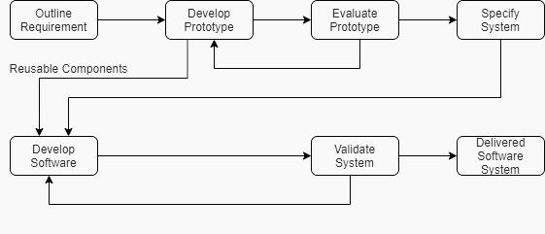

The methodology used in this study is the Prototyping Developmental Method. In this methodology, a prototype is defined with the primary or selected function to see the result and to discover what is missing in the project. A prototype of a software project must be developed quickly and often ignores best programming practices (Saed S., et al, 2019). It is a model that focuses on developing an initial prototype and refining the design before that development. Prototyping Development includes seven phases and as follows:

**Requirements Phase (Outline Requirement)**

Chapter III 26

In this development phase, the researchers brainstormed the ideas and requirements for the project development. It starts by identifying the problems encountered by the beneficiary. After the said process, the team proceeds with the proper data gathering through a face-to-face interview with the beneficiary. After gathering the current issues, the team proposes the solutions and requirements for the current problem before finalizing the needs. The objectives are identified to strengthen further the criteria needed for the project development.

**Prototyping Phase (Develop Prototype)**

In this phase, the team creates a prototype of how the system will look like. The team builds the interface of the pages accurately for each intended end user. The Prototype created is the initial output shown to the beneficiary for their approval and feedback. The developers started creating the Prototype using drawings, wireframes, and mock-ups.

**Evaluation Phase (Evaluate Prototype)**

After the developer creates the Prototype, the team then presents it to the beneficiary to gather insights and suggestions according to the beneficiary's preferences and needs. Then, after initiating changes, the team finalizes the user interface design that the development team will follow upon creating the system.

**Review and Refine (Specify System Phase)**

Chapter III 27

After the beneficiary's evaluation and feedback, the team proceeds to refine the system prototype. In this phase, the team identified the final look and interface of the system for specific end users. A final prototype is made. Then, the Prototype was presented to the beneficiary for approval before the actual development.

**Development Phase (Develop Software)**

In this phase, the team's programmer starts to write the codes for the system to function according to the objectives, needs, and requirements. After completing the first fifty percent (50%) of the system development, the team lets the beneficiary assess the system to see if it works according to the agreed system functions and design. The team also reviewed the system to measure its capability to function. After gathering the suggestions and insights of the beneficiary, the team then proceeds with the modifications and updates. After completing it, the team's programmer then completes the remaining fifty percent (50%) of the system that needs to be accomplished.

**Testing Phase (Validation)**

After completion, the team reviews the system to catch errors, assess the interface, and measure the functions before the beta testing. It is to ensure that before the end users use the system, little to no errors are ideal to appear. The team will conduct their testing using test cases.

It include testing the features, such as the functions, inputs and outputs, and buttons. Additionally, IT experts are adhered to test the system using the system quality assurance tool. The tool ISO 25010 (SQuaRE) encompasses eight (8) components used to measure the system's overall function. After the team tests the system, it will also be presented to the beneficiary and the end users for them to utilize it and measure the functions, design, and information provided by the system using the PSSUQ questionnaire. If the beneficiary wishes to make other changes, the development team then catered to the suggestions and update the system according to the beneficiary's aims. After the modifications, the team and the beneficiary tested the system again.

Chapter III 28

**Release Phase (Deliver System)**

In this phase, the team delivers the fully developed system for the beneficiary. The deployment followed a specific agreement between the developers and the beneficiary. The training for the end users also took place in this phase. It is to ensure the users are fully aware and knowledgeable on how to correctly use the system and be more productive while using it.

**3****.2 Operational Framework**

Chapter III 29

**Figure 2**

*Operational Framework of IOT Based Restaurant Information System*

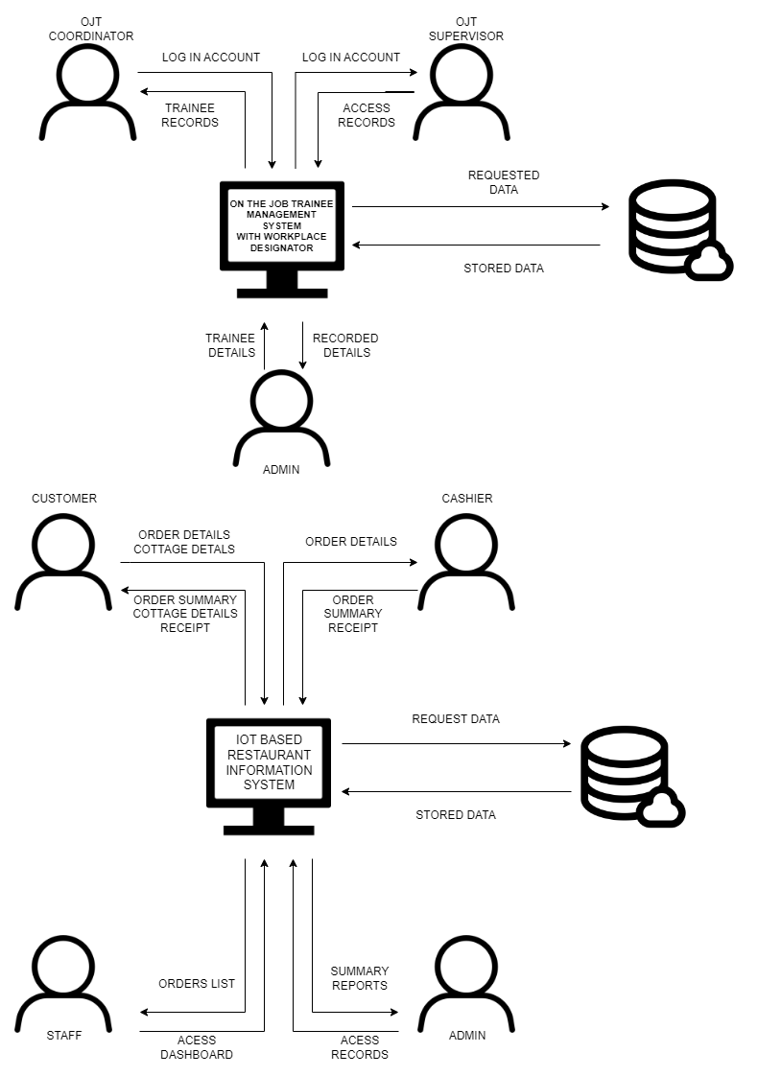

The figure above shows the developed Operational Framework of the system. The customer inputs the order and cottage details using the system, and after processing the data, the summary is reflected in the customer's interface; the cashier will view these data for further confirmation of the order and cottage reservation. The order and cottage reservation record are sent to the admin interface. The cashier can still manually input order details into the system, where the summary and receipt will then be retrieved after processing the said order, and the data is sent to the admin interface for records. The data provided, modified, added, and saved by the users will all be stored on the cloud database available for viewing by specific system users once needed.

Chapter III 30

**3.3 Context Diagram (Level 0)**

**Figure 3**

*Context Level Data Flow Diagram of IOT Based Restaurant Information System*

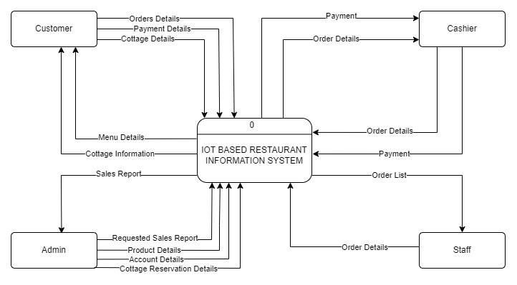

The figure above shows the context diagram of the system. It includes the main processes held while the users are utilizing the system. It consists of the data provided and the data outputs. The users of the system are the customer/s, the cashier, the kitchen staff, and the system administrator.

**3.4 Data Flow Diagram (Level 1)**

Chapter III 31

**Figure 4**

*Level 1 Data Flow Diagram of IOT Based Restaurant Information System*

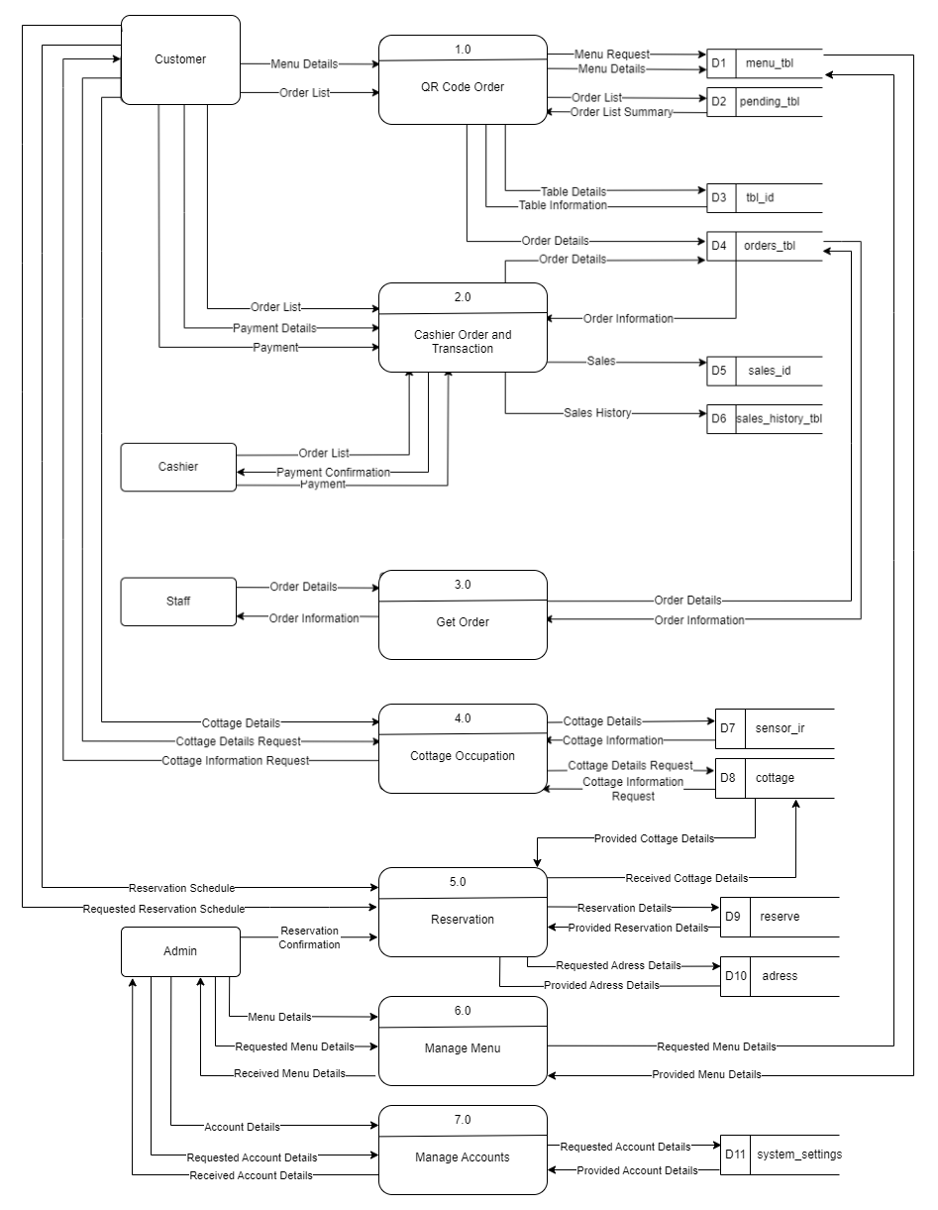

The figure above shows the Level 1 Data Flow Diagram of the system. It illustrates the data that flows between the end users, such as the customer and the cashier. The included processes in the figure, also known as the sub-processes, were derived from the context diagram.

Chapter III 32

**3.5 Entity Relationship Diagram**

**Figure 5**

*Entity Relationship Diagram of IOT Based Restaurant Information System*

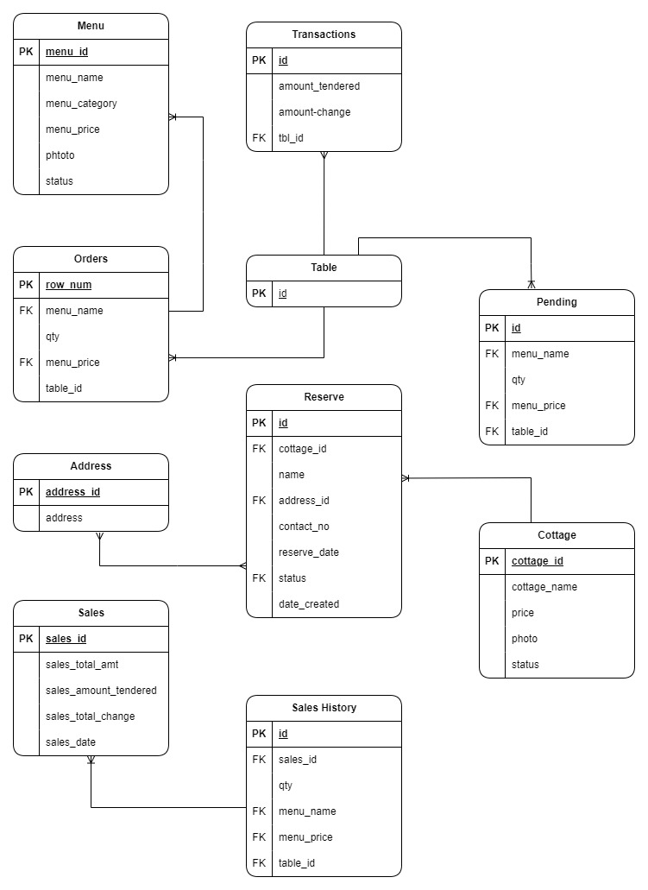

The figures represent the entity relationship diagram of the system. The diagram represents the relationship of entities/tables in the database. The diagram ensures the database architecture is correctly visualized so stakeholders know the data relationships clearly.

Chapter III 33

**3.6 Use Case Diagram**

Chapter III 34

**Figure 6**

*Use Case Diagram of IOT Based Restaurant Information System*

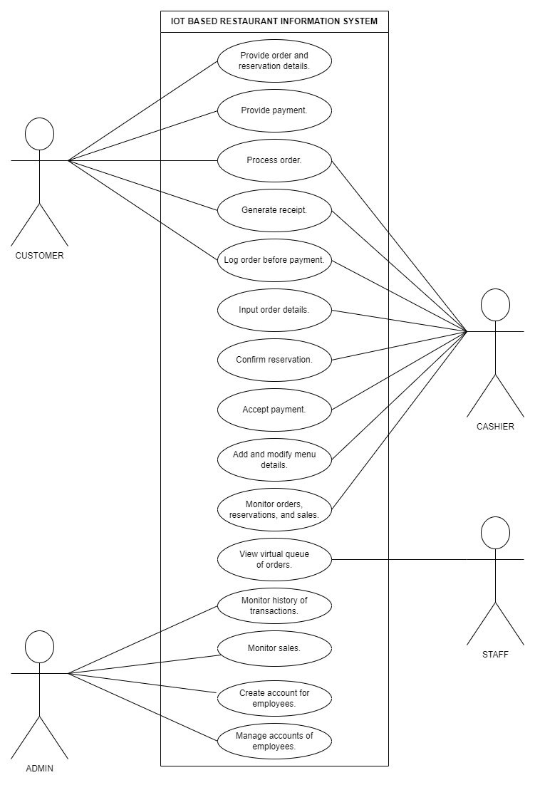

The figure above shows the use case diagram of the system. It represents how the users can simultaneously interact with the system. The scenarios are specified according to the intended end users.

**3.7 Data Dictionary**

Chapter III 35

Data Dictionary includes detailed data about the business. This includes the standard name of data elements, their meaning, and allowable values.

**Table 1**

*Menu*

|  |  |  |  |  |  |
| --- | --- | --- | --- | --- | --- |
| **Field** | **Optional** | **Field Type** | **Length** | **Key** | **Description** |
| menu_id | No | Integer | 11 | PK | Unique identifier of menu. |
| menu_name | Yes | Varchar | 30 |  | Specific name of menu. |
| menu_category | Yes | Text | 30 |  | Category of menu item. |
| menu_price | Yes | Float | 6,2 |  | Price of the menu item. |
| photo | yes | Image |  |  | Photo of the specific menu. |
| status | Yes | Text | 11 |  | Availability of menu item. |

**Table 2**

*Pending*

|  |  |  |  |  |  |
| --- | --- | --- | --- | --- | --- |
| **Field** | **Optional** | **Field Type** | **Length** | **Key** | **Description** |
| row_num | No | Integer | 11 | PK | Unique identifier of pending reservation. |
| menu_name | Yes | Varchar | 11 | FK | Specific name of menu. |
| Qty | Yes | Integer | 11 |  | Quantity of pending reservation. |
| table _id | No | Integer | 11 | FK | Unique identifier of table. |

**Table 3**

*Table*

|  |  |  |  |  |  |
| --- | --- | --- | --- | --- | --- |
| **Field** | **Optional** | **Field Type** | **Length** | **Key** | **Description** |
| table _id | No | Integer | 11 | FK | Unique identifier of table. |

**Table 4**

*Orders*

|  |  |  |  |  |  |
| --- | --- | --- | --- | --- | --- |
| **Field** | **Optional** | **Field Type** | **Length** | **Key** | **Description** |
| id | No | Integer | 11 | PK | Unique identifier of pending order. |
| menu_name | Yes | Varchar | 30 |  | Specific name of menu. |
| qty | Yes | Integer | 11 |  | Quantity of orders. |
| menu_price | Yes | Float | 6,2 |  | Price of the menu item. |
| orders_qty | Yes | Integer | 11 |  | Quantity of orders. |

**Table 5**

Chapter III 36

*Sales*

|  |  |  |  |  |  |
| --- | --- | --- | --- | --- | --- |
| **Field** | **Optional** | **Field Type** | **Length** | **Key** | **Description** |
| sales_id | No | Integer | 11 | PK | Unique identifier of sales. |
| sales_total_amt | Yes | Float | 6,2 |  | Total amount of sales. |
| sales_total_change | Yes | Float | 6,2 |  | Amount tendered minus total amount of order. |
| sales_date | No | Date |  |  | Date when sales was made. |

**Table 6**

*Sales History*

|  |  |  |  |  |  |
| --- | --- | --- | --- | --- | --- |
| **Field** | **Optional** | **Field Type** | **Length** | **Key** | **Description** |
| id | No | Integer | 11 | PK | Unique identifier. |
| sales_id | No | Integer | 11 | FK | Unique identifier of sales. |
| Qty | Yes | Integer | 11 |  | Quantity of orders. |
| menu_name | Yes | Varchar | 30 |  | Specific name of menu. |
| menu_price | Yes | Float | 6,2 |  | Price of the menu item. |
| table _id | No | Integer | 11 | FK | Unique identifier of table. |

**Table 7**

*Sensor IR*

|  |  |  |  |  |  |
| --- | --- | --- | --- | --- | --- |
| **Field Name** | **Optional** | **Field Type** | **Length** | **Key** | **Description** |
| id | No | Integer | 11 | PK | Unique identifier. |
| status | Yes | Text | 30 |  | Availability of the cottage. |
| cottage_id | No | Integer | 11 | FK | Unique identifier of table. |

**Table 8**

*Cottage*

|  |  |  |  |  |  |  |
| --- | --- | --- | --- | --- | --- | --- |
| **Field** | **Optional** | **Field Type** | | **Length** | **Key** | **Description** |
| cottage_id | No | | Integer | 11 | PK | Unique identifier of table. |
| cottage_name | Yes | | Text | 30 |  | Specific name of cottage. |
| price | Yes | | Float | 6,2 |  | Price of the cottage. |
| status | Yes | | Text | 30 | FK | Availability of the cottage. |
| photo | Yes | | Image |  |  | Image of the specific cottage. |

**Table 9**

Chapter III 37

*Reserve*

|  |  |  |  |  |  |
| --- | --- | --- | --- | --- | --- |
| **Field Name** | **Optional** | **Field Type** | **Length** | **Key** | **Description** |
| id | No | Integer | 11 | PK | Unique identifier. |
| cottage_id | No | Integer | 11 | FK | Unique identifier of table. |
| name | Yes | Text | 255 |  | Name of the customer. |
| address_id | No | Integer | 11 | FK | Address id of the customer. |
| contact_no | Yes | Varchar | 30 |  | Contact number of the customer. |
| reserve_date | Yes | Date |  |  | Reservation date. |
| status | Yes | Tiny Integer | 4 | FK | Status of the cottage. |
| date_created | Yes | Date |  |  | Date reservation was created. |

**Table 10**

*Address*

|  |  |  |  |  |  |
| --- | --- | --- | --- | --- | --- |
| **Field** | **Optional** | **Field Type** | **Length** | **Key** | **Description** |
| address_id | No | Integer | 11 | PK | Address id of the customer. |
| address | Yes | Text | 255 |  | Address of the customer. |

**Table 11**

*System Settings*

|  |  |  |  |  |  |
| --- | --- | --- | --- | --- | --- |
| **Field** | **Optional** | **Field Type** | **Length** | **Key** | **Description** |
| id | No | Integer | 30 | PK | Unique identifier. |
| name | Yes | Text | 25 |  | Name of the user. |
| email | Yes | Varchar | 200 |  | Email of the user. |
| contact | Yes | Varchar | 20 |  | Contact number of the user. |

**Table 12.**

Chapter III 38

*Transactions*

|  |  |  |  |  |  |
| --- | --- | --- | --- | --- | --- |
| **Field** | **Optional** | **Field Type** | **Length** | **Key** | **Description** |
| id | No | Integer | 11 | PK | Unique identifier of transaction. |
| amount_tendered | Yes | Float | 10,2 |  | Amount given by customer to pay for purchase. |
| amount_change | Yes | Float | 10,2 |  | Change of customer from amount tendered. |
| table _id | No | Integer | 11 | FK | Unique identifier of table. |

**Table 13.**

*User*

|  |  |  |  |  |  |
| --- | --- | --- | --- | --- | --- |
| **Field** | **Optional** | **Field Type** | **Length** | **Key** | **Description** |
| id | No | Integer | 11 | PK | Unique identifier of user. |
| name | Yes | Varchar | 16 |  | Specific name of user. |
| username | Yes | Varchar | 16 |  | Username of the user account. |
| password | Yes | Varchar | 16 |  | Password of user account. |
| name | Yes | Varchar | 16 |  | Specific account name of user. |

**3.8 Hardware and Software Requirements**

Hardware and Software Requirements provide detailed minimum requirements needed to support the developed system’s functions and executions.

**Recommended Software Requirements**

Chapter III 39

The following is the list of software requirements utilized by the proponents that support the function and the proposed system’s executions.

* Microsoft Edge Browser / Google Chrome Browser / Opera Mini Browser / Mozilla Firefox Browser
* Windows 10 Operating System
* Android / iOS Browser
* Android / iOS Operating System

**Recommended Minimum Hardware Requirement**

The following is the list of hardware requirements utilized by the proponents that support the function and the proposed system’s executions.

* Intel Core i3, 2.4Ghz (4GB or above RAM Storage 250GB HDD / 128GB SSD or above ROM Storage) 1366 x 768 Resolution
* Ethernet Connection: LAN or Wireless Adapter (Wi-Fi)
* Android 8 or above / iOS 6 and above Mobile Phone (2GB RAM Storage, 16GB ROM Storage)
* Android 8 or above / iOS 6 and above Tablet (2GB RAM Storage, 16GB ROM Storage)
* Arduino – Raspi 4 (Broadcom BCM2711, Quad core Cortex-A72 (ARM v8) 64-bit SoC @ 1.8GHz)
* PIR Sensors (Input voltage: DC 4.5-20V, Static current: 50ua, Sensing range: Max 7 m)

**3.9 Time Table (Gantt Chart)**

Chapter III 40

**Table 14**

**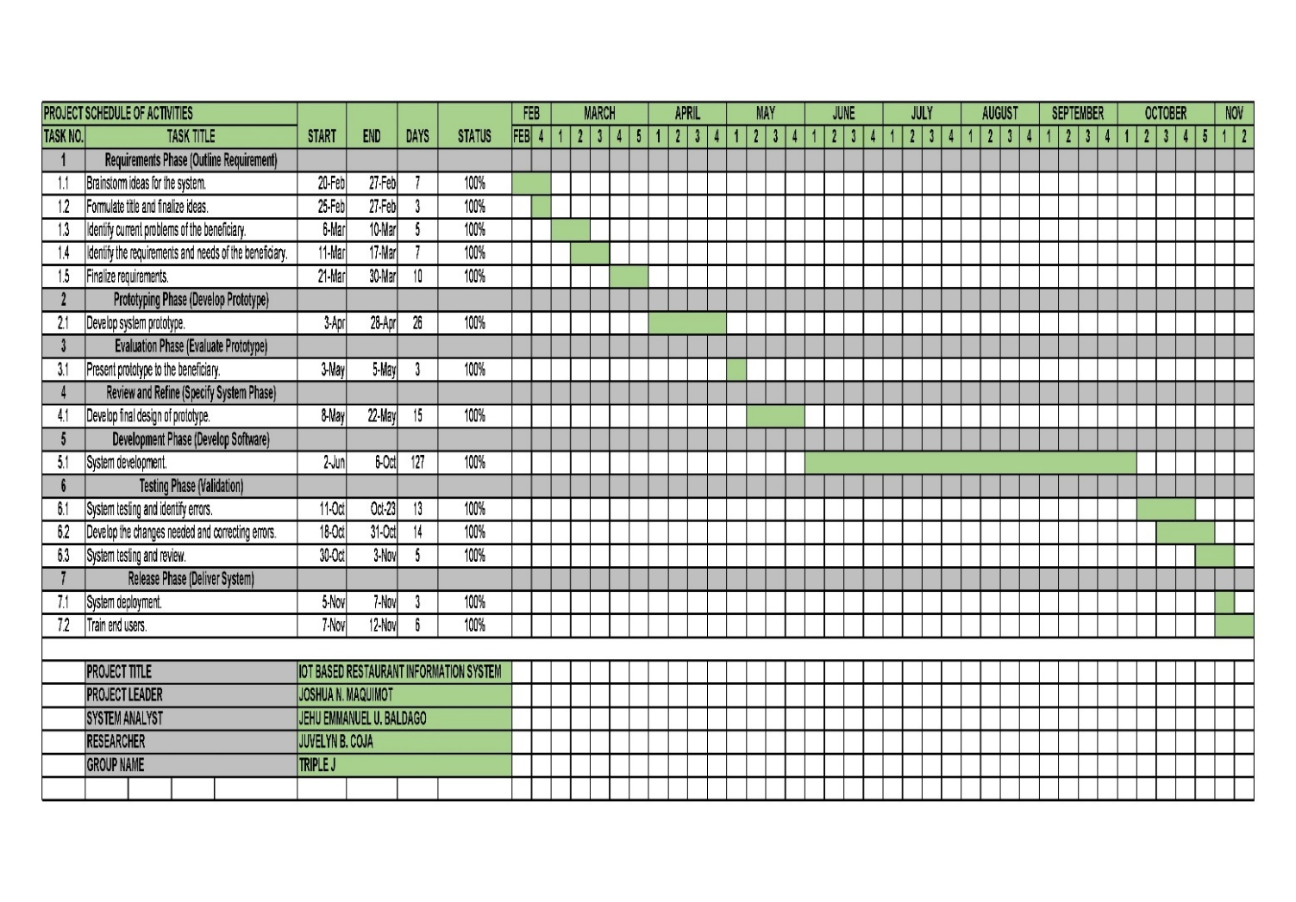***Gantt Chart of IOT Based Restaurant Information System*

The table above illustrates the project schedule of activities for the project development. It encompasses seven (7) phases that follow the Prototyping Model development methodology. The seven (7) phases are the Requirements Phase (Outline Requirement), Prototyping Phase (Develop Prototype), Evaluation Phase (Evaluate Prototype), Review and Refine (Specify System Phase), Development Phase (Develop Software), Testing Phase (Validation), and Release Phase (Deliver System) that incorporate the tasks done by the team members to complete the project development within a specific period of timeline.

**3.10 System Usability and Reliability Testing**

Chapter III 41

System usability and reliability testing was conducted to assess the IOT Based restaurant information system's overall function. The testing was done to ensure that the system will work functionally according to the objectives and requirements needed by the business. The testing determines if the system has no errors and if it is easy, understandable, and convenient to use. Fifteen (15) respondents were asked to evaluate the developed system. The non-IT professionals were the system's possible end users.

The Post-Study System Usability Questionnaire was used as the basis for testing the overall functionality and usability of the system by end users. The PSSUQ includes sixteen (16) questions that will reflect the overall functionality of the system in accordance with the objectives of this study. System Usefulness will determine the system's usability if it complies with the proposed functions. The Information Quality will assess if the information provided by the system is adequate, accurate, and valuable. The Interface Quality were examined to prove that the system's user interface is easy to utilize, understand, and navigate. These factors will contribute to the evaluation of the system's overall usability.

Additionally, three (3) IT experts were asked to evaluate the system's functionality. It were a standard criterion to determine the quality and consistency of the developed system if it satisfies or exceeds the stated needs and requirements. Test cases will also be used with the experts to assess the system's overall functionality the system is easy to utilize, understand and navigate. These factors will contribute to the evaluation of the system’s overall usability.

Chapter III 42

Seven (7) Point Likert Scale with Verbal Interpretation

|  |  |  |  |
| --- | --- | --- | --- |
| **Responses** | **Scale** | **Range** | **Verbal Interpretation** |
| Strongly Agree (SA) | 1 | 1:00 – 1.84 | Very High (VH) |
| Agree (A) | 2 | 1.85 – 2.69 | High (H) |
| Slightly Agree (SLA) | 3 | 2.70 – 3.54 | Above Average (AA) |
| Undecided (U) | 4 | 3.55 - 4.39 | Average (A) |
| Slightly Disagree (SLD) | 5 | 4.40 - 5.24 | Below Average (BA) |
| Disagree (DA) | 6 | 5.25 - 6.09 | Low (L) |
| Strongly Disagree (SDA) | 7 | 6.10 - 7.00 | Very Low (VL) |

The researchers used the assessment tool ISO 25010 (SQuaRE) for the overall system design and development. ISO 25010 (SQuaRE) quality model consists of 8 (eight) software quality characteristics: Functional Suitability, Performance Efficiency, Compatibility, Reliability, Usability, Security, Maintainability, and Portability. These components are the basis of the Software's quality. The primary purpose of conducting a system evaluation is to assess the system's functionality. These quality characteristics are also subdivided into more comprehensive sub-characteristics, which are the basis for measuring the system's quality and contribute to evaluating the system's overall usability.

Chapter III 43

|  |  |
| --- | --- |
| **Mean Score** | **Verbal Interpretation** |
| 4.21-5.00 | Excellent |
| 3.41.4.20 | Very Highly Acceptable |
| 2.61.-3.40 | Highly Acceptable |
| 1.81-2.60 | Acceptable |
| 1.-1.80 | Not Acceptable |

**CHAPTER IV**

**Results and Discussions**

This chapter contains the following: profile of the respondents, description of the system prototype, system testing results using the PSSUQ questionnaire and ISO 25010 (SQuaRE) software quality assurance tool, and the User's Manual. This chapter discusses managing and utilizing the system and its interrelated systems and other specifications.

**4.1 Profile of the Respondents**

The respondents of this study include fifteen (15) system end users and three (3) IT experts that tested and evaluated the system according to their perspective and evaluation about the system.

**Table 15. Profile of the Respondents**

|  |  |  |
| --- | --- | --- |
| **Respondent Type** | **No. Of Respondents** | **%** |
| Customer | 12 | 66.6% |
| Staff | 3 | 16.7% |
| IT Experts | 3 | 16.7% |
| **Total** | **18** | **100%** |

The respondents of this study include fifteen (15) system end users and three (3) IT experts who tested and evaluated the system according to their perspectives and evaluation about the system.

Chapter IV 45

Table 15 above shows the profile of the respondents. There are fifteen (15) respondents associated with MC Seafood Restaurant. All fifteen (15) respondents evaluated the system's usability using the PSSUQ questionnaire. Additionally, three (3) IT experts assessed the system's functionality with the use of the ISO 25010 (SQuaRE) system quality assurance tool.

**4.2 Screen Prototype and Description**

This part includes the description of the screen layout of the system. These include the designs that need the recommended hardware and software requirements to run correctly.

**Figure 7**

Chapter IV 46

*Website Homepage*

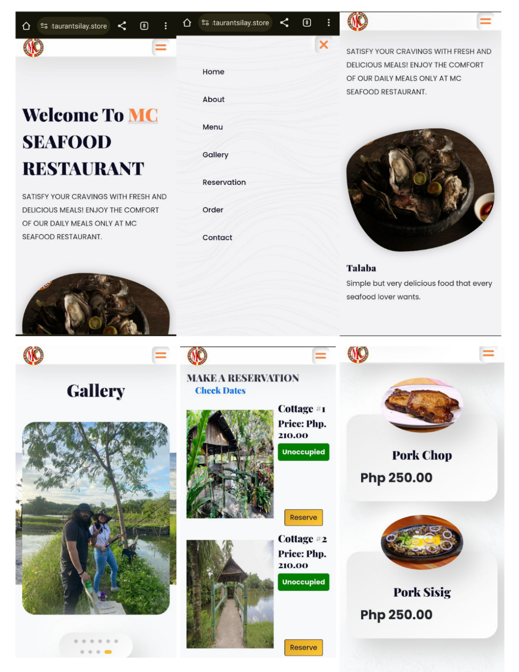

Figure 7 shows the main home page of the system's website. This can be accessed once the customer scans the QR code on each table or cottage. On this page, customers can browse meals by scrolling down the website and viewing the restaurant's online gallery.

Chapter IV 47

**Figure 8**

**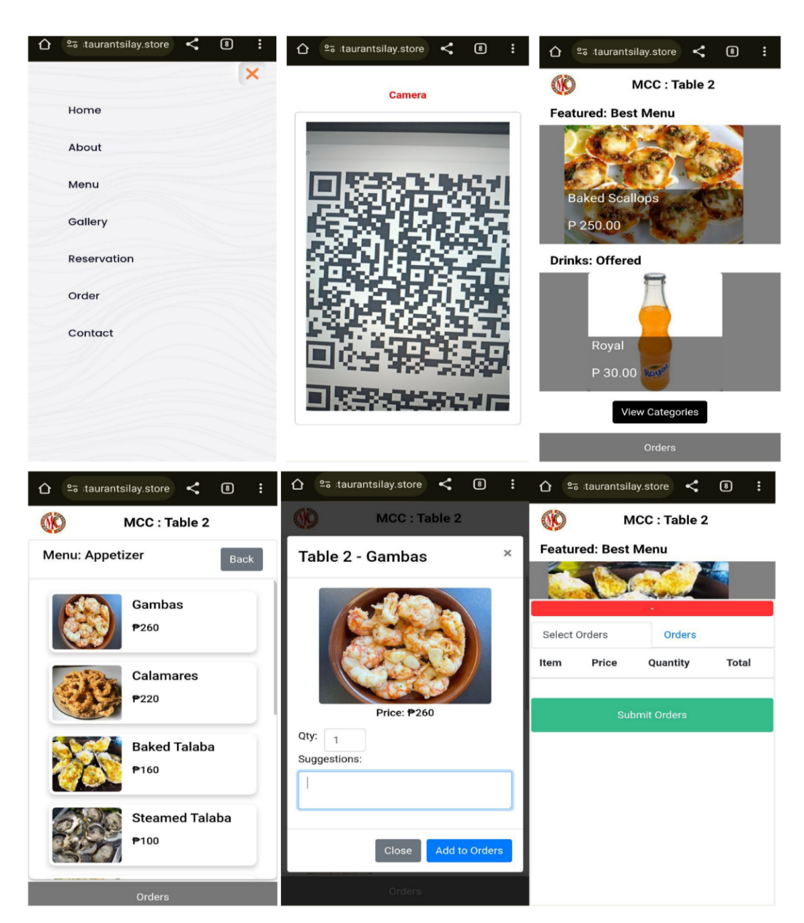***Ordering Page for Customer*

Figure 8 shows the order page for the customer. It is where they can order meals after scanning the QR code that will direct them to this page. They can choose to pay over the counter or online.

**Figure 9**

Chapter IV 48

*Cottage Reservation Page*

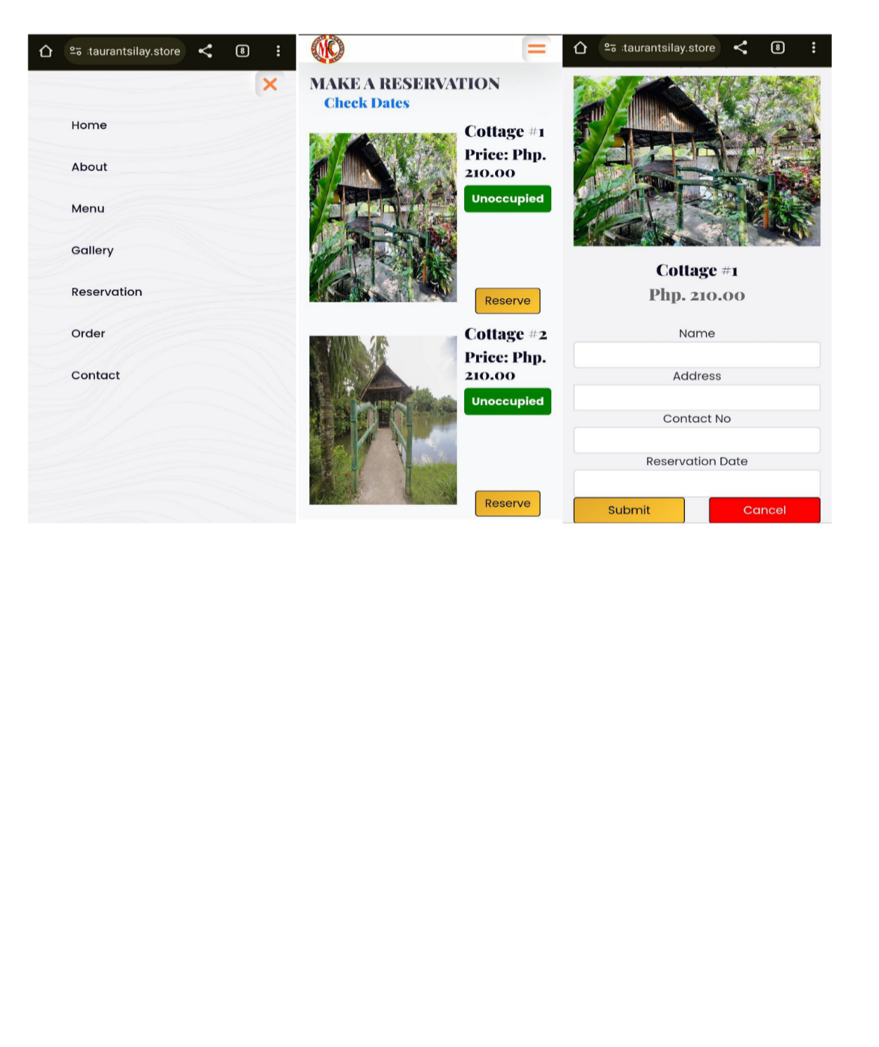

Figure 9 shows the page where the customer can reserve a cottage. It was using their mobile phone. The customers can identify the cottage's availability, and they can book the cottage by filling out the form.

**Figure 10**

Chapter IV 49

*Admin Dashboard*

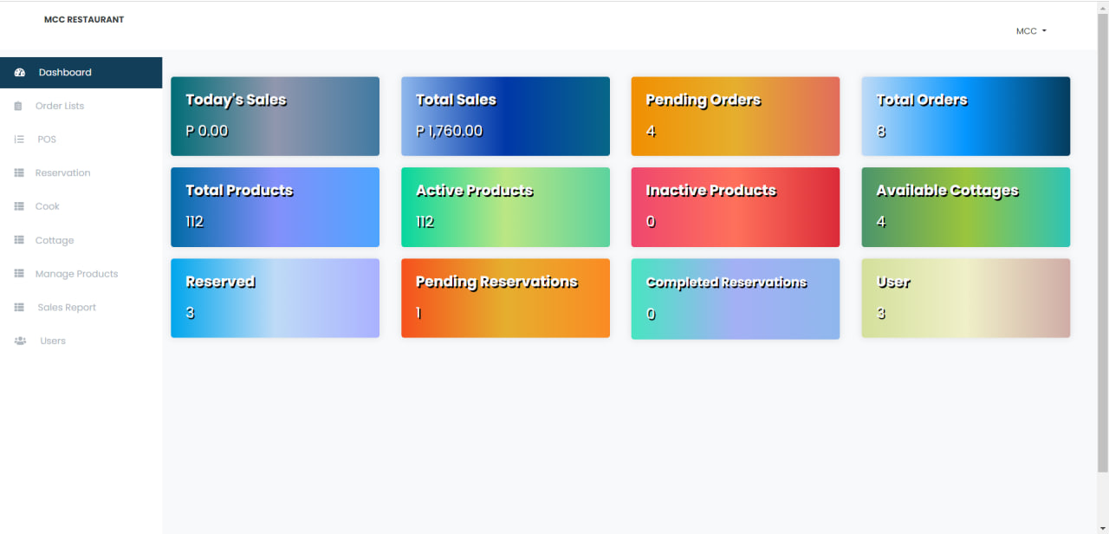

Figure 10 shows the admin dashboard. In this dashboard, the admin can see the sales, orders, products, cottages, reservations, and users. The staff page can still work like the admin page; however, there are limitations due to the availability of data that can be accessed by staff.

**Figure 11**

Chapter IV 50

*Staff Dashboard*

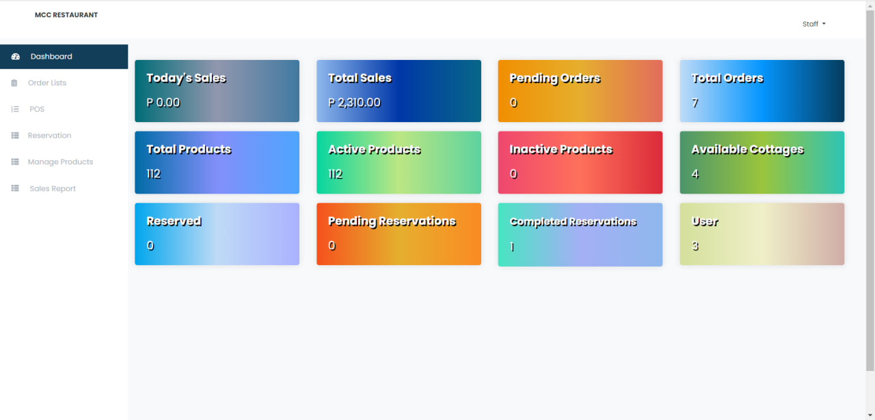

Figure 11 shows the admin dashboard. The admin can see the sales, orders, products, cottages, reservations, and users in this dashboard. The staff page can still work like the admin page. However, there are limitations due to the availability of data that staff can access.

**Figure 12**

Chapter IV 51

*Point of Sales*

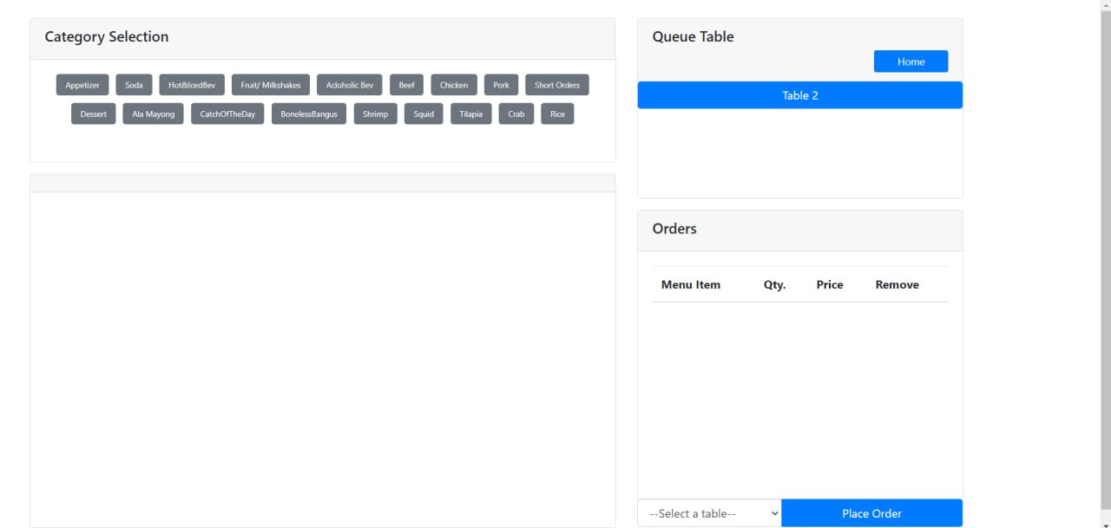

Figure 12 shows the point-of-sales system that can be accessed by the admin and the cashier/staff. They log in on the website first. This is the page where the input of orders was done on the staff's end.

**Figure 13**

*Kitchen Staff Virtual Queue Page*

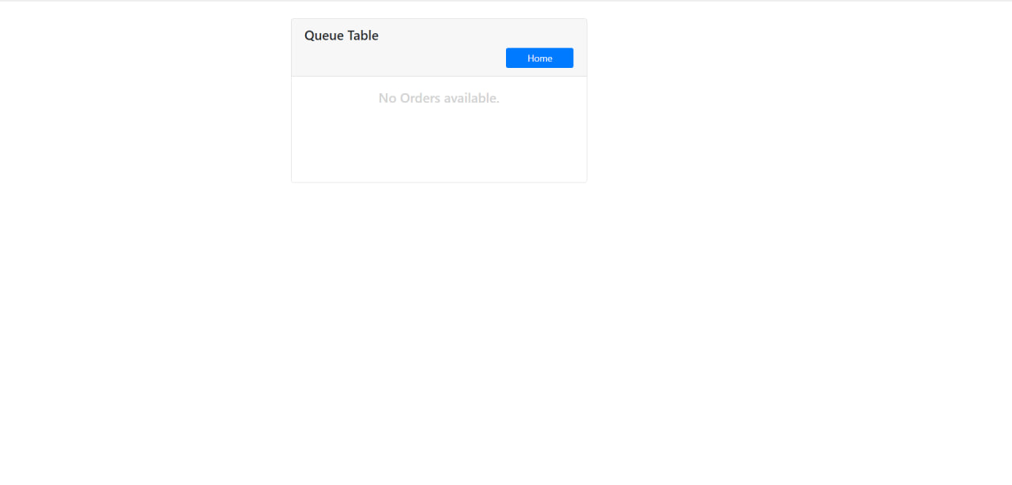

Figure 13 shows the virtual queue for the kitchen staff. On this page, the orders done by customers are accessed by the staff. They can easily manage the number of meals to prepare.

**Figure 14**

Chapter IV 52

*QR Code*

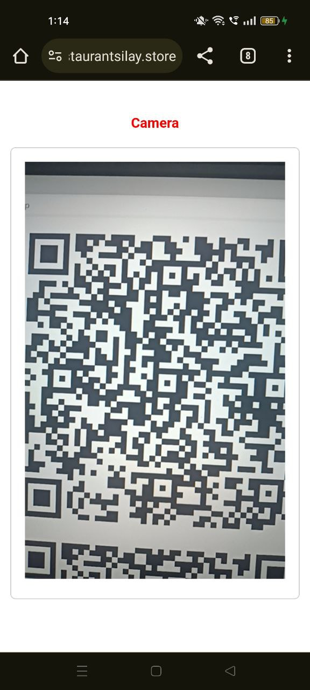

Figure 14 shows the Q.R. code sample. It can be scanned using the phone to access the mobile phone-based ordering page. This code is available for mobile phones.

**4.3 System Testing Results**

Chapter IV 53

The second objective of this study is to test the functionality of the aforementioned features using the ISO 25010 (SQuaRE) evaluation tool for system design and development for experts in terms the system's functionalities.

**Table 16**

*Mean Scores in the ISO 25010 (SQuaRE) Evaluation of IOT Based Restaurant Information System*

|  |  |
| --- | --- |
| **ISO 25010 (SQuaRE) Component** | **Mean Score** |
| Functional Suitability | 3.7 |
| Performance Efficiency | 4.11 |
| Usability | 3.9 |
| Reliability | 4.01 |
| Security | 4.12 |
| Maintainability | 4.01 |
| Portability | 4 |
| Compatibility | 3.7 |
| Overall Mean Score | 3.94 |

Based on the mean scores from the ISO 25010 (SQuaRE) evaluation results, the overall mean score of the IOT Based Restaurant Information System is rated with a result of 3.94. Security criterion got the highest mean score of 4.12. Meanwhile, Compatibility and Functional Suitability got the lowest mean score of 3.7, which indicates that the system needs to improve more on that criterion.

**Table 17**

Chapter IV 54

*Mean Scores in the Usability Level of IOT Based Restaurant Information System*

|  |  |
| --- | --- |
| **PSSUQ Criteria** | **Mean Score** |
| System Usefulness | 1.73 |
| Information Quality | 2.03 |
| Interface Quality | 1.61 |
| Overall Usability | 1.8 |

Table 17 shows the mean scores on the system's usability level. Most end users rated the System's Usefulness with a "Strongly Agree" remark with a mean score of 1.73. The rate of the system's Information Quality resulted in a "Strongly Agree" remark with a 2.03 mean score. The Information Quality was rated "Strongly Agree," with a mean score of 1.61. Lastly, the Overall Usability is remarked as "Strongly Agree," with a mean score of 1.8. The results served as the basis for the system's level of acceptability.

Table 17 shows the PSSUQ Norm. The PSSUQ Norm is the mean scores data collected and compared with other systems. This provides a reference comparison if the system studied and developed is comparable or better than the rest (with 99% interval)

To conform to the industry requirements, the mean scores achieved by the System should be within the specified mean score ranges in the PSSUQ Norm.

**Table 18**

Chapter IV 55

*PSSUQ - 3 Norms (Means and 99% Confidence Level Interval)*

|  |  |  |  |
| --- | --- | --- | --- |
|  | PSSUQ (Current) | | |
| Item | Lower Limit | Mean | Upper Limit |
| Q1 | 2.60 | 2.85 | 3.09 |
| Q2 | 2.45 | 2.69 | 2.93 |
| Q3 | 2.58 | 2.85 | 3.11 |
| Q4 | 2.86 | 3.16 | 3.45 |
| Q5 | 2.79 | 3.06 | 3.34 |
| Q6 | 2.40 | 2.66 | 2.91 |
| Q7 | 2.07 | 2.27 | 2.48 |
| Q8 | 2.54 | 2.86 | 3.17 |
| Q9 | 3.36 | 3.70 | 4.05 |
| Q10 | 2.93 | 3.21 | 3.49 |
| Q11 | 2.65 | 2.96 | 3.27 |
| Q12 | 2.79 | 3.09 | 3.38 |
| Q13 | 2.37 | 2.61 | 2.86 |
| Q14 | 2.46 | 2.74 | 3.01 |
| Q15 | 2.41 | 2.66 | 2.92 |
| Q16 | 2.06 | 2.28 | 2.49 |
| Q17 | 2.18 | 2.42 | 2.66 |
| Q18 | 2.51 | 2.79 | 3.07 |
| Q19 | 2.55 | 2.82 | 3.09 |
| SysUse | 2.57 | 2.80 | 3.02 |
| InfoQual | 2.79 | 3.02 | 3.24 |
| IntQual | 2.28 | 2.49 | 2.71 |
| Overall | 2.62 | 2.82 | 3.02 |

**Table 19**

Chapter IV 56

*Mean scores in the Usability of IOT Based Restaurant Information System as a Whole*

|  |  |
| --- | --- |
| Criteria | M |
| 1. Overall, I am satisfied with how easy it is to use this system. | 1.6 |
| 2. It was simple to use this system. | 1.73 |
| 3. I was able to complete the tasks and scenarios quickly using this system. | 1.86 |
| 4. I felt comfortable using this system. | 1.66 |
| 5. It was easy to learn to use this system. | 1.66 |
| 6. I believe I could become productive quickly using this system. | 1.86 |
| 7. The system gave error messages that clearly told me how to fix problems. | 2.4 |
| 8. Whenever I made a mistake using the system, I could recover easily and quickly. | 2.46 |
| 9. The information (such as online help, on-screen messages, and other documentation) provided with this system was clear. | 1.53 |
| 10. It was easy to find the information I needed. | 1.8 |
| 11. The information was effective in helping me complete the tasks and scenarios. | 2.06 |
| 12. The organization of information on the system screens was clear. | 1.93 |
| 13. The interface of this system was pleasant. | 1.66 |
| 14. I liked using the interface of this system. | 1.73 |
| 15. This system has all the functions and capabilities I expect it to have. | 1.66 |
| 16. Overall, I am satisfied with this system. | 1.4 |
| As a whole | 1.8 |

Shown in Table 19 are the results of the survey from the respondents. After computing the mean scores of the different subscales, the strength of deviation of whether the system is up to the accepted standard was then normalized to the PSSUQ Norm shown in Table 18.

Chapter IV 57

Table 19 presents the summary of mean scores on the level of usability of the IOT-based Restaurant Information System as a whole and evaluated by twelve (12) customers of MC Seafood Restaurant and three (3) staff. The level of overall usability of the system is remarked as "Strongly Agree" (M = 1.8). The questionnaire used a seven-point response scale, with lower scores indicating better performance. The average mean score of the Overall Usability of 1.8 is higher than the mean score for the Overall Usability based on the PSSUQ Norm 3, which is 2.82. This result indicates that the system meets the industry standard requirements.

**System Usefulness**

Table 20 shows the summary of responses from items 1 to 6 of the usability questionnaire. These items were the basis for identifying the System Usefulness (SYSUSE). Item #1 achieved the highest perceived mean, indicating that most of the respondents are satisfied overall with how easy it is to learn and use the system.

**Table 20**

Chapter IV 58

*Summary of the mean scores in System Usefulness of the System*

|  |  |
| --- | --- |
| Criteria | M |
| 1. Overall, I am satisfied with how easy it is to use this system. | 1.6 |
| 2. It was simple to use this system. | 1.73 |
| 3. I was able to complete the tasks and scenarios quickly using this system. | 1.86 |
| 4. I felt comfortable using this system. | 1.66 |
| 5. It was easy to learn to use this system. | 1.66 |
| 6. I believe I could become productive quickly using this system. | 1.86 |
| ***System Usefulness (SYSUSE)*** | 1.73 |

Based on the mean scores from items 1 to 6, the System Usefulness of the IOT-based Restaurant Information System is 1.73. Item #1 got the highest mean score of 1.6. Meanwhile, items #3 and #6 got the lowest mean score of 1.86, which indicates that the system needs to improve more on that criterion.

**Information Quality**

Table 21 shows the summary of responses from items 7 to 12 of the usability questionnaire. These items were the basis for identifying the Information Quality (INFOQUAL). Item #9 achieved the highest perceived mean, indicating that most of the respondents are satisfied with how easy it is to locate and access the information they need associated with the system.

**Table 21**

Chapter IV 59

*Summary of the mean scores in Information Quality of the System*

|  |  |
| --- | --- |
| Criteria | M |
| 7. The system gave error messages that clearly told me how to fix problems. | 2.4 |
| 8. Whenever I made a mistake using the system, I could recover easily and quickly. | 2.46 |
| 9. The information (such as online help, on-screen messages, and other documentation) provided with this system was clear. | 1.53 |
| 10. It was easy to find the information I needed. | 1.8 |
| 11. The information was effective in helping me complete the tasks and scenarios. | 2.06 |
| 12. The organization of information on the system screens was clear. | 1.93 |
| ***Information Quality (INFOQUAL)*** | 2.03 |

Based on the mean scores from items 7 to 12, the Information Quality of the IOT-Based Restaurant Information System is rated with a mean of 2.03. Item #9 got the highest mean score of 1.56. Meanwhile, item #8 got the lowest mean score of 2.46, which indicates that the system needs to improve more on that criterion.

**Interface Quality**

Chapter IV 60

Table 22 shows the summary of responses from items 13 to 16 of the usability questionnaire. These items were the basis for identifying the Interface Quality (INTERQUAL). Item #16 achieved the highest perceived mean, indicating that most of the respondents are satisfied overall with how easy it is to locate and access the interfaces they see that are associated with the system.

**Table 22**

*Summary of the mean scores in Interface Quality of the System*

|  |  |
| --- | --- |
| Criteria | M |
| 13. The interface of this system was pleasant. | 1.66 |
| 14. I liked using the interface of this system. | 1.73 |
| 15. This system has all the functions and capabilities I expect it to have. | 1.66 |
| 16. Overall, I am satisfied with this system. | 1.4 |
| ***Interface Quality (INTERQUAL)*** | 1.61 |

Based on the mean scores from items 13 to 16, the Interface Quality of the IOT-Based Restaurant Information System is rated with a result of 1.61. Item #16 got the highest mean score of 1.4. Meanwhile, item #14 got the lowest mean score of 1.73, which indicates that the system needs to improve more on that criterion.

**4.4 Development of the User Manual**

Chapter IV 61

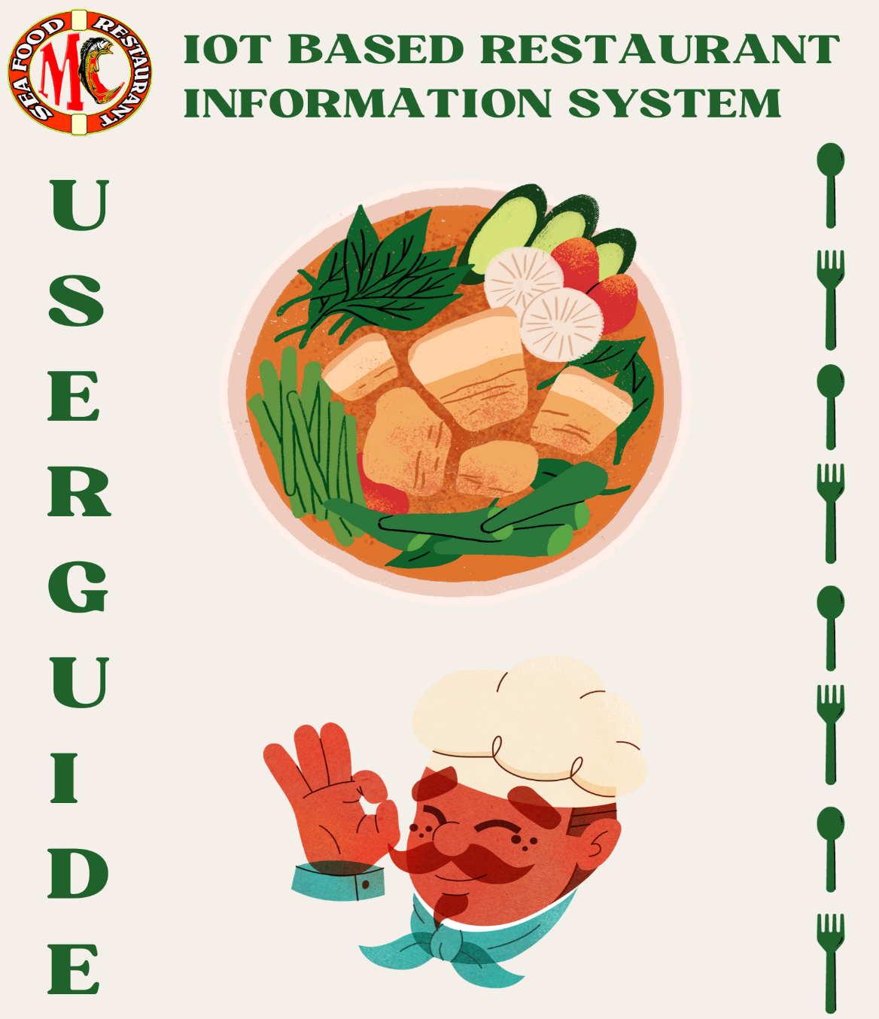

The fourth objective of the study was to develop a user manual for IOT Based Restaurant Information System. The system's user manual includes essential information and a detailed description of using the system and its parts. The manual encompasses the chronological order of the system's flow. See Appendix E for complete details of the user's manual.

**CHAPTER V**

**Summary of Findings, Conclusion and Recommendation**

This chapter presents and discusses the overall summary of results and findings, the conclusions, and the recommendation of the study regarding the results of the gathered information on the implementation of the IOT Based Restaurant Information System.

**5.1 Summary of Findings**

The IOT Based Restaurant Information System was developed, including the following technical features: sensor-based reservation for the cottage, point of sales, in-house Q.R. code-based ordering, virtual queue for orders, menu listing, and sales and reservation monitoring. The customers of MC Seafood Restaurant, its staff members, and IT experts evaluated the IOT Based Restaurant Information System based on the aforementioned technical features. The evaluation concluded that the system's overall performance is confirmed to meet their expectation. The PSSUQ questionnaire results showed a total mean score of 1.8. It is evaluated that the majority of the respondents strongly agree that the IOT Based Restaurant Information System does have a high capacity for usability. On the first criterion, System Usefulness, which covers questions 1 to 6, the mean score is 1.73. The second criterion, named Information Quality, covers the questions from 7 to 12; the mean score result is 2.03. The third criterion, Interface Quality, covers the questions from 13 to 16; the mean score is 1.61. Meanwhile, the ISO 25010 (SQuaRE) system quality assurance result garnered a total evaluation of "Very Highly Acceptable" remark with a 3.94 score.

Chapter V 63

The system's user manual includes essential information and a detailed description of how to use the system and its parts. The manual encompasses the chronological order of the system's flow.

**5.2 Conclusion and Recommendation**

This part discusses the conclusion based on the four objectives that need to be achieved prior to developing this system. Researchers give recommendations for each objective.

**Objective 1**: To design and develop an IOT Based restaurant information system

with the following technical features: sensor-based availability for cottages, point of sales, in-house QR code-based ordering, virtual queue for orders, menu listing, and sales and reservation monitoring.

**Conclusion:** The developed system helps to improve the overall business flow of

the restaurant as technological-based tools and methods were implemented to optimize their ways of work. The system will automate their tasks, such as ordering, presenting the virtual queue, making online cottage reservations using sensors, recording orders, and monitoring sales.

**Recommendation:** The researchers recommend that MC Seafood Restaurant

and future researchers consider adding e-payment methods for each transaction and implement sensors on tables for online reservations.

Chapter V 64

**Objective 2**: Testing using the ISO 25010 (SQuaRE) evaluation tool for system

design and development by experts in terms of functional suitability, performance efficiency, compatibility, usability, reliability, security, maintainability and, portability.

**Conclusion:** The system features completed the testing process. The IT experts

evaluated the IOT Based Restaurant Information System based on the aforementioned technical features using the ISO 25010 (SQuaRE) evaluation tool, the system achieved a total mean of 3.94 with a "Very Highly Acceptable" remark.

**Recommendation:**  The developed features of the IOT Based Restaurant

Information System are confirmed to be helpful. The result shows a "Very Highly Acceptable" remarks. Researchers may consider upgrading the system features in the future.

**Objective 3**: Test the usability of the system by end-users in terms of system

usefulness, information quality, interface quality, and overall usability.

**Conclusion:** The evaluation of IOT Based Restaurant Information System using

the PSSUQ questionnaire with the criteria of System Usefulness, Information Quality, Interface Quality, and Overall Usability shows the results of the mean scores of the system according to the criteria needed. It is evaluated that the majority of the respondents strongly agree that the IOT Based Restaurant Information System does have a high capacity for usability. On the first criterion, System Usefulness, which covers questions 1 to 6, the mean score is 1.73. The second criterion, named Information Quality, covers the questions from 7 to 12; the mean score result is 2.03. The third criterion, Interface Quality, covers the questions from 13 to 16; the mean score is 1.61. The mean for the Overall Usability resulted in a mean score of 1.8.

Chapter V 65

**Recommendation:** The developed IOT Based Restaurant Information System

was feasible since the result mean is higher than the PSSUQ norms, which is 2.82.

**Objective 4:**  Develop a user’s manual.

**Conclusion:** The created user manual were helpful to the proponents of this

system as it will serve as their guide on how to use and execute the technical features of this system properly.

**Recommendation:** The researchers recommend the use of a user manual

intended to help and guide the users in operating the system.

**References**

Dewi, I. A., Miftahuddin, Y., Fattah, M. H., Palenda, C. B., & Erawan, S. D. (2021). Point of Sales System in InHome Café Website using Agile Methodology. Journal of Innovation and Community Engagement. <https://doi.org/10.28932/jice.v1i1.3321>

Intal, G. L., Payas, J. D., Fernandez, L. M., & Domingo, B. M. (2020). Restaurant Information System (RIS) with QR Code to Improve Service Operations of Casual Fine Dining Restaurant. <https://doi.org/10.1109/ICIEA49774.2020.9102036>

Kim, B., Yoo, M. J., & Yang, W. (2020). Online Engagement Among Restaurant Customers: The Importance of Enhancing Flow for Social Media Users. Journal of Hospitality & Tourism Research. <https://doi.org/10.1177/1096348019887202>

Liyanage, V., Ekanayake, A., Premasiri, H., Munasinghe, P. & Thelijjagoda, S. (2018). Foody – Smart Restaurant Management and Ordering System. <https://ieeexplore.ieee.org/abstract/document/8629835/>

Luciano, R. G., Alcantara, G. M., & Bauat, R. (2024). Design And Development Of Alumni Tracking System For Public And Private Heis. <https://www.academia.edu/download/89519344/Design-And-Development-Of-Alumni-Tracking-System-For-Public-And-Private-Heis.pdf>

Masa, J. R. (2021). Predictors of customer satisfaction and behavioral intention of themed restaurants in Manila, Philippines. <https://www.researchgate.net/publication/319205639_Experiential_Dining_Customer_Behavior_of_Selected_Themed_Restaurants_in_Manilaion_of_Themed_Restaurants_in_Manila/links/621ebaf17106690c085320cd/Predictors-of-Customer-Satisfaction-and-Behavioral-Intention-of-Themed-Restaurants-in-Manila>

Mendoza, A. R., Santos, T. M., Balbuena, A. R., Cabral, B., & Agustin, L. F. (2019). Point Of Sale System with Inventory for Arm’s Food and Delicacies. <https://www.researchgate.net/publication/337707746_POINT_OF_SALE_SYSTEM_WITH_INVENTORY_FOR_ARM’S_FOOD_AND_DELICACIES>

Nandre, M., Patil, D., Patil, K. (2019). IOT Based Restaurant Automation System. <https://ijrti.org/papers/IJRTI1906003.pdf>

Nord, J. H., Koohang, A., & Paliszkiewicz, J. (2019). The Internet of Things: Review and theoretical framework. Expert Systems with Applications <https://doi.org/10.1016/j.eswa.2019.05.014>

Pandey, S., Ansari, Z., Niranjan, A., Singh, A., & Goel, N. (2021). Automated Restaurant System Using IoT. <https://ijirt.org/master/publishedpaper/IJIRT152049_PAPER.pdf>

Pinpin-Lucero, P. R. (2020). Perception of Stakeholders on the Adoption of 4th Industrial Revolution Technologies in the Hospitality Industry in the Philippines. In Perspectives on Asian tourism. <https://doi.org/10.1007/978-981-19-4497-0_8>

Saeed, S., Jhanjhi, N. Z., Naqvi, M., & Humayun, M. (2019). Analysis of software development methodologies. International Journal of Computing and Digital Systems, 8(5), 446-460.

Sun, K., Zhao, Q., & Zou, J. (2020). A review of building occupancy measurement

systems. Energy and Buildings, 216, 10996. <https://doi.org/10.1016/j.enbuild.2020.109965>

Warlina, L., & Noersidik, S. M. (2018). Designing Web-based Food Ordering Information System in Restaurant. https://doi.org/10.1088/1757-899x/407/1/012029

APPENDICES

**Appendix A**

**PSSUQ Questionnaire**

Testing Evaluation Instrument for IOT Based Restaurant Information System

Name (Optional): Occupation (Optional):

Age: User Type:

This questionnaire will determine how usable the IOT Based Restaurant Information System in terms of System Usefulness, Information Quality and Interface Quality.

Direction: On a scale from 1-3 with Strongly Agree remarks, 4 with Neutral remark, 5-7 with Strongly Disagree, and N/A remark, please rate the following statement according to how you feel about the system:

|  |  |  |  |  |  |  |  |  |
| --- | --- | --- | --- | --- | --- | --- | --- | --- |
| PSSUQ Questions | 1 | 2 | 3 | 4 | 5 | 6 | 7 | N/  A |
| 1. Overall, I am satisfied with how easy it is to use this system. |  |  |  |  |  |  |  |  |
| 2. It was simple to use this system. |  |  |  |  |  |  |  |  |
| 3. I was able to complete the tasks and scenarios quickly using this system. |  |  |  |  |  |  |  |  |
| 4. I felt comfortable using this system. |  |  |  |  |  |  |  |  |
| 5. It was easy to learn to use this system. |  |  |  |  |  |  |  |  |
| 6. I believe I could become productive quickly using this system. |  |  |  |  |  |  |  |  |
| 7. The system gave error messages that clearly told me how to fix problems. |  |  |  |  |  |  |  |  |
| 8. Whenever I made a mistake using the system, I could recover easily and quickly. |  |  |  |  |  |  |  |  |
| 9. The information (such as online help, on-screen messages, and other documentation) provided with this system was clear. |  |  |  |  |  |  |  |  |
| 10. It was easy to find the information I needed. |  |  |  |  |  |  |  |  |
| 11. The information was effective in helping me complete the tasks and scenarios. |  |  |  |  |  |  |  |  |
| 12. The organization of information on the system screens was clear. |  |  |  |  |  |  |  |  |
| 13. The interface of this system was pleasant. |  |  |  |  |  |  |  |  |
| 14. I liked using the interface of this system. |  |  |  |  |  |  |  |  |
| 15. This system has all the functions and capabilities I expect it to have. |  |  |  |  |  |  |  |  |
| 16. Overall, I am satisfied with this system. |  |  |  |  |  |  |  |  |

Legend:

Questions 1 to 16: Overall Usability

Questions 1 to 6: System Usefulness (SYSUSE)

Questions 7 to 12: Information Quality (INFOQUAL)

Questions 13 to 16: Interface Quality (INTERQUA)

**Appendix B**

**ISO 25010 (SQuaRE) Evaluation Tool**

Name (Optional):

Years in the IT Industry:

Please rate the following ISO 25010 (SQuaRE)components according to the system’s performance. One (1) as the lowest and five (5) as the highest.

|  |  |  |  |  |  |
| --- | --- | --- | --- | --- | --- |
| ISO 25010 (SQuaRE) Component | 1 | 2 | 3 | 4 | 5 |
| 1. 1. Functional Suitability |  |  |  |  |  |
| 1. 2. Performance Efficiency |  |  |  |  |  |
| 1. 3. Compatibility |  |  |  |  |  |
| 4. Usability |  |  |  |  |  |
| 1. 5. Reliability |  |  |  |  |  |
| 1. 6. Security |  |  |  |  |  |
| 1. 7. Maintainability |  |  |  |  |  |
| 1. 8. Portability |  |  |  |  |  |

**Appendix C**

**Letter To Beneficiary**



**Appendix D**

**Letter For Capstone Adviser**

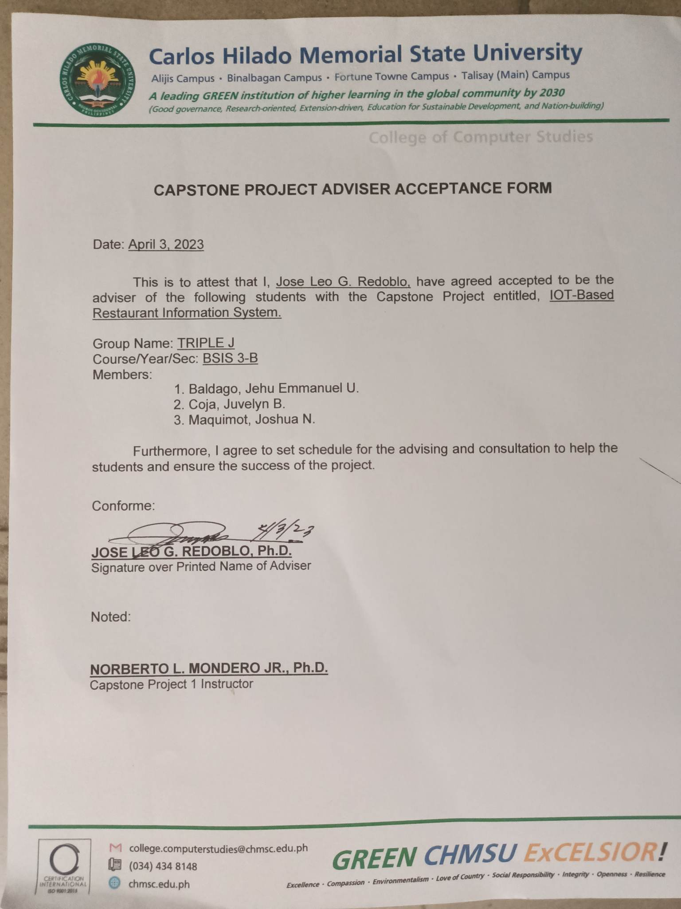

**Appendix E**

**User Manual**

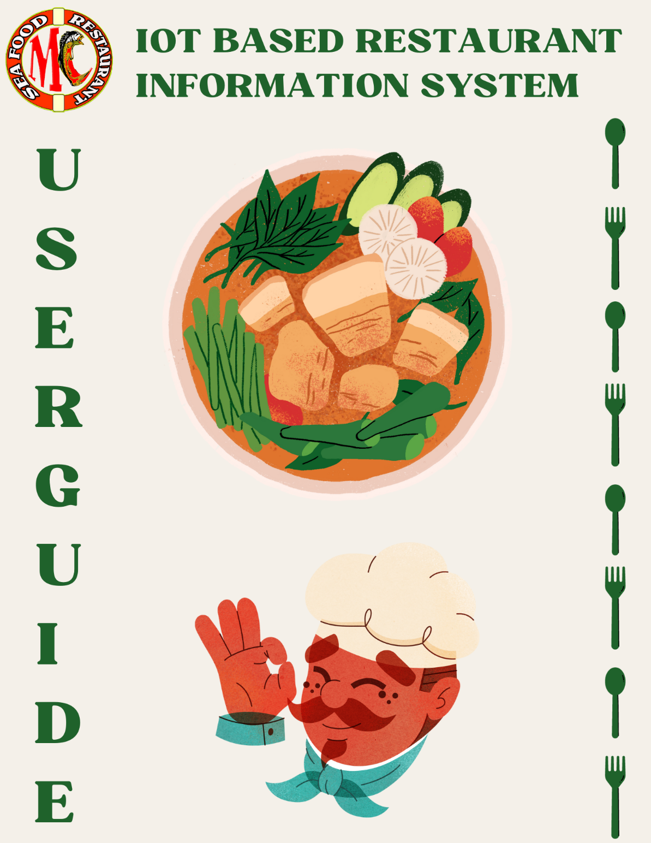

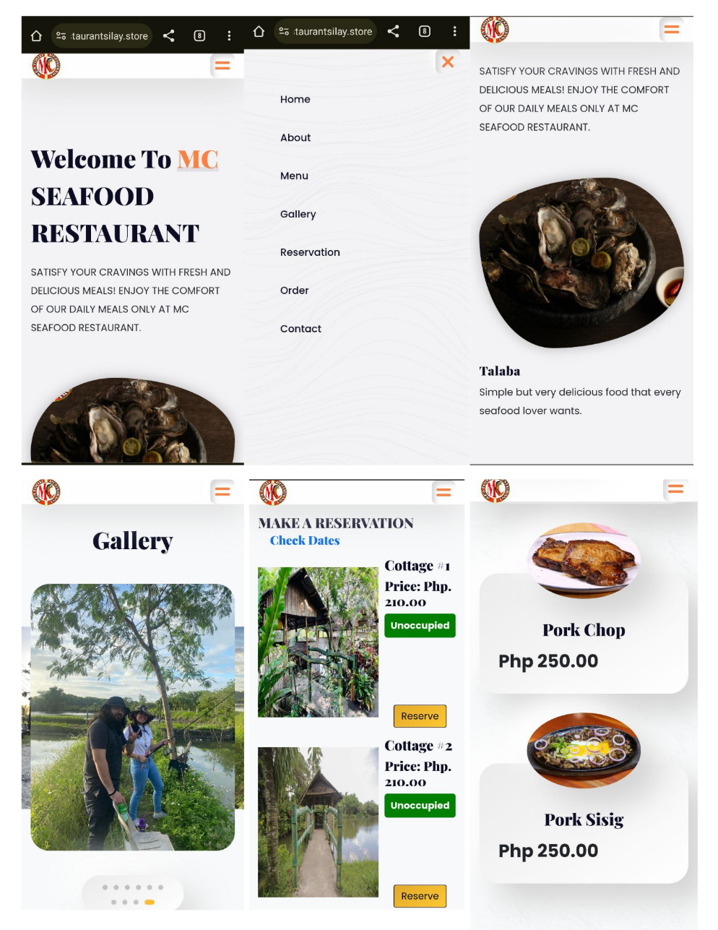

8

7

6

5

4

3

1

2

How To Use the Website

Step 1: Search the website link

Step 2: Go to website

Step 3: Click the two-line icon at the upper right side

Step 4: Click about to see about the restaurant

Step 5: Click menu to see the menu list of the restaurant

Step 6: Click gallery to view the highlights in the restaurant

Step 7: Click reservation to view the available cottage and to reserve a cottage

Step 8: Click order to prompt in QR code scanner for online inhouse table QR ordering

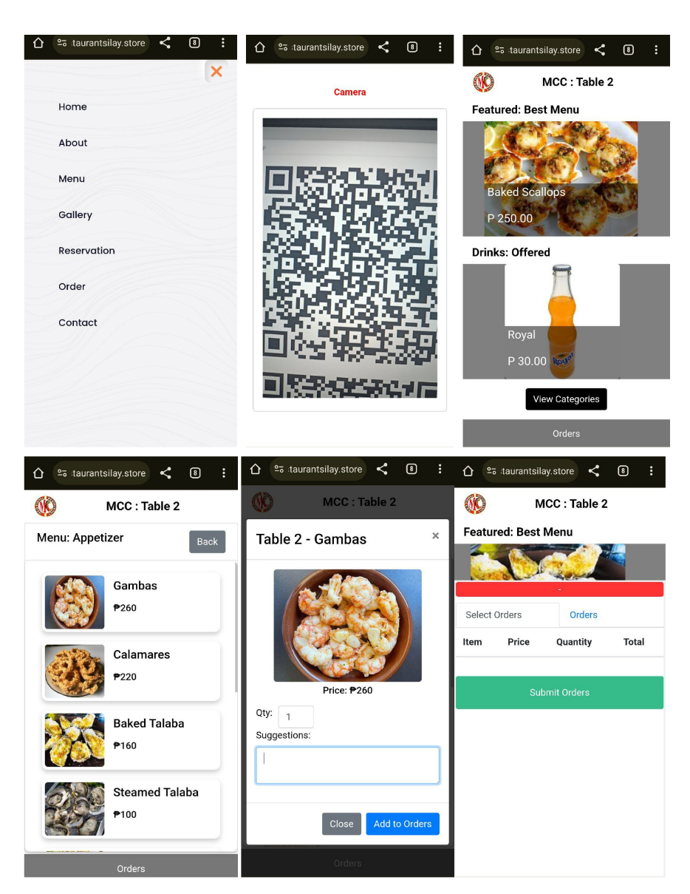

9

8

7

6

5

4

3

2

1

How To Order Online

Step 1: Click order

Step 2: Scan QR code

Step 3: Click view category

Step 4: Click product

Step 5: Add quantity

Step 6: Create suggestion(optional)

Step 7: Add to cart Step

Step 8: Click orders

Step 9: Click submit orders

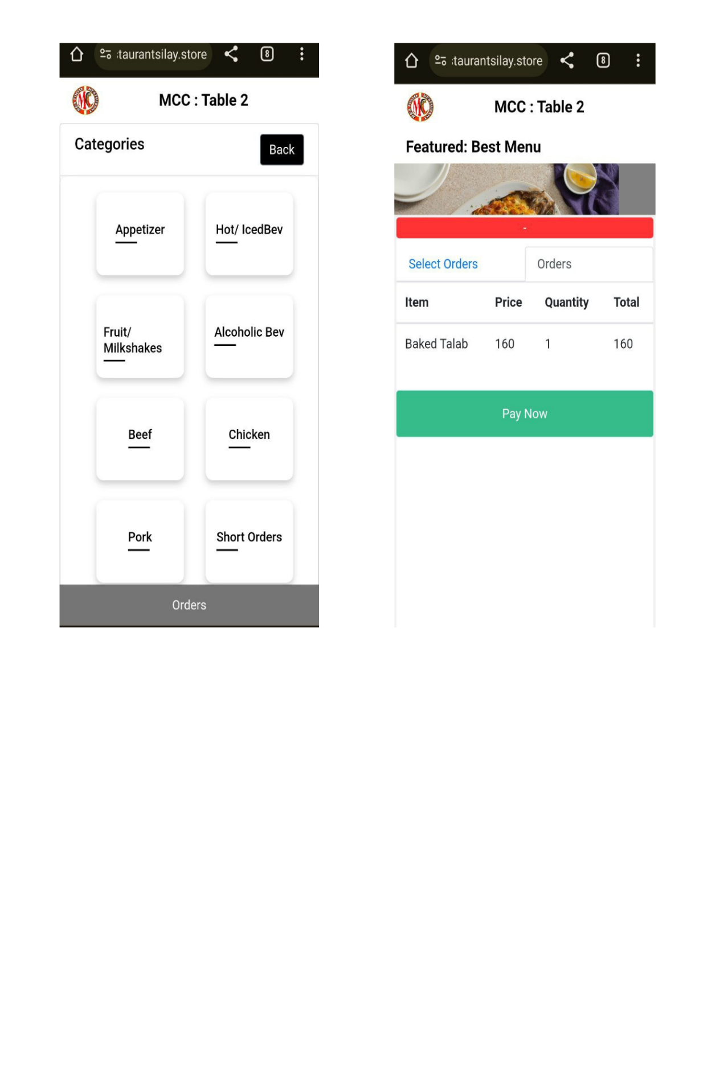

3

2

1

How To Pay In Mobile

Step 1: Click orders tab

Step 2: Click orders

Step 3: Pay now

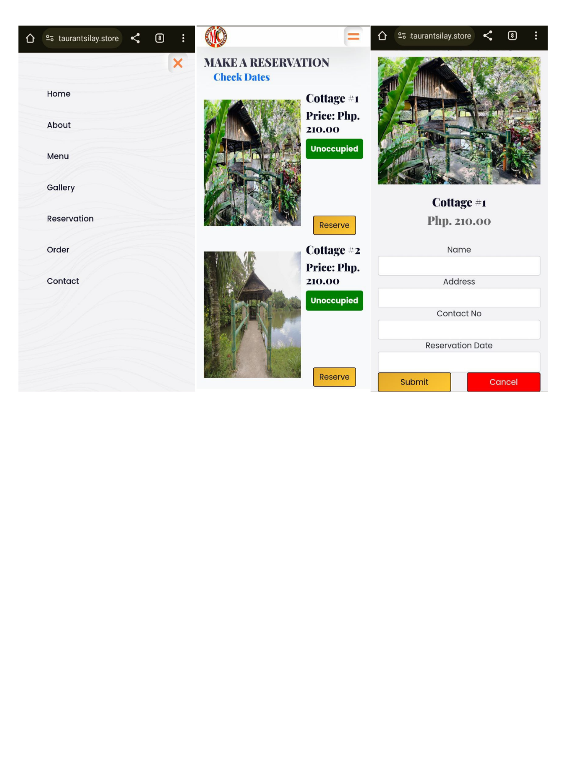

4

3

2

1

How To Make Reservations

Step 1: Click reservation

Step 2: Click reserve

Step 3: Fill all the required field

Step 4: Click Submit Step

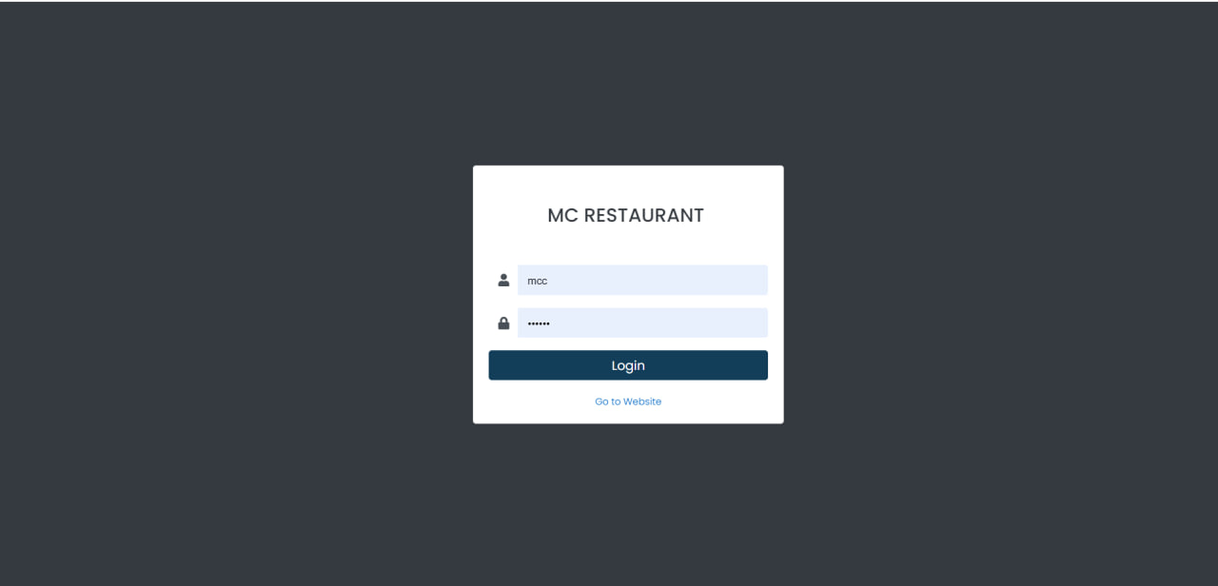

3

2

1

How To Access The Dashboard

Step 1: Enter user credentials

Step 2: Click login

Step 3: Locate dashboard pages

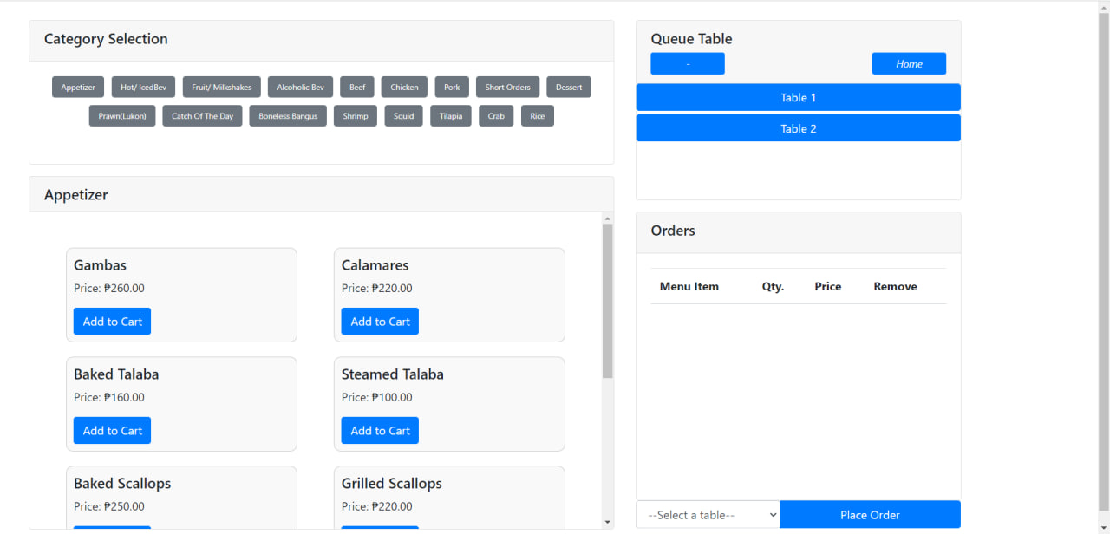

4

3

2

1

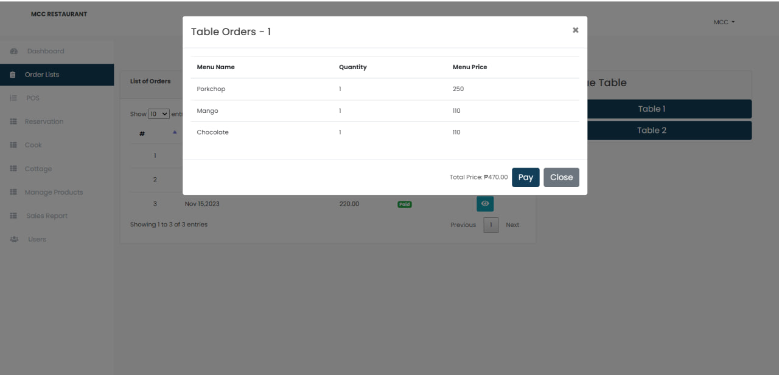

6

5

How To Process Order

Step 1: Select category

Step 2: Select product

Step 3: Select table

Step 4: Click add to cart

Step 5: Select and click in queue table

Step 6: Click pay

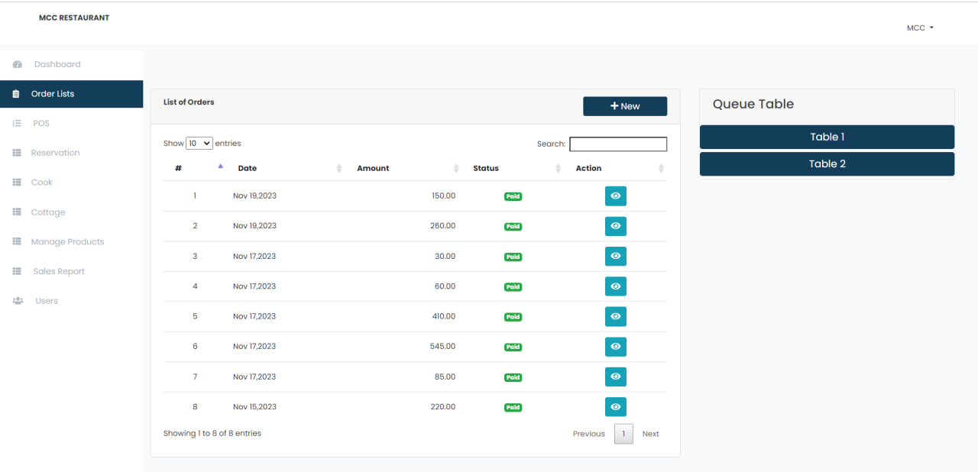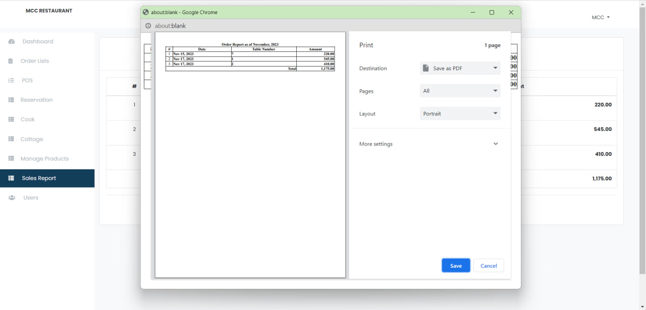

3

2

1

How To Generate Receipt

Step 1: Click order list

Step 2: Click eye icon

Step 3: Tab keys for print

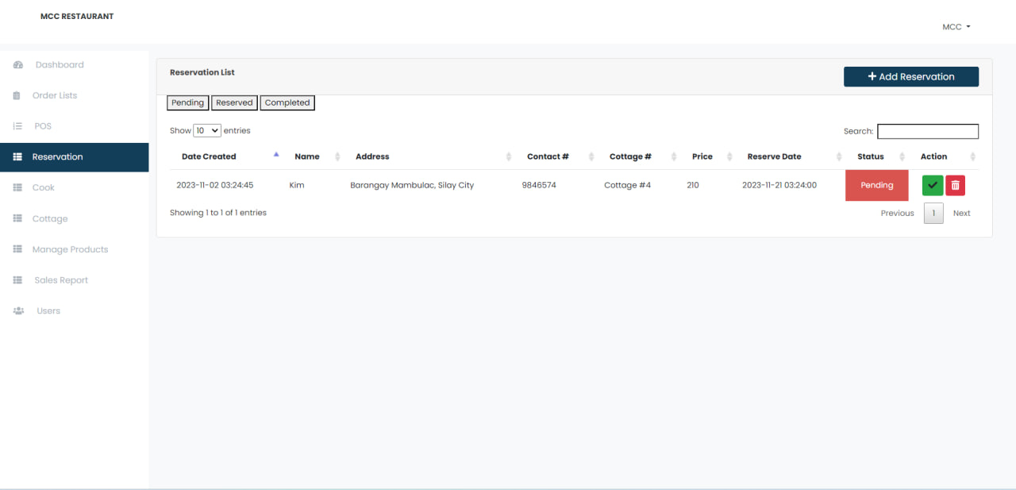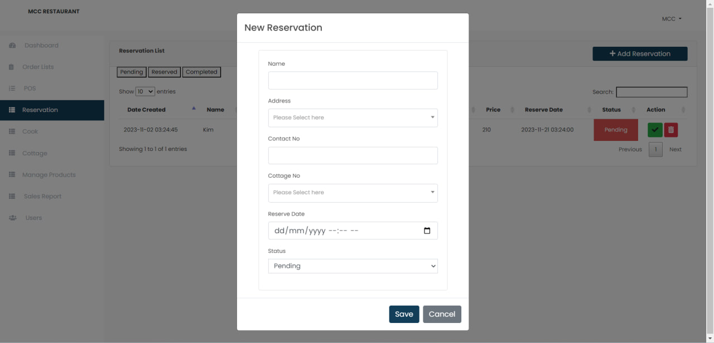

5

4

3

2

1

How To Process Reservation

Step 1: Click reservations

Step 2: Click add reservation

Step 3: Fill all the field

Step 4: Click save

Step 5: Click pending

Step 6: Click check icon in status to check out

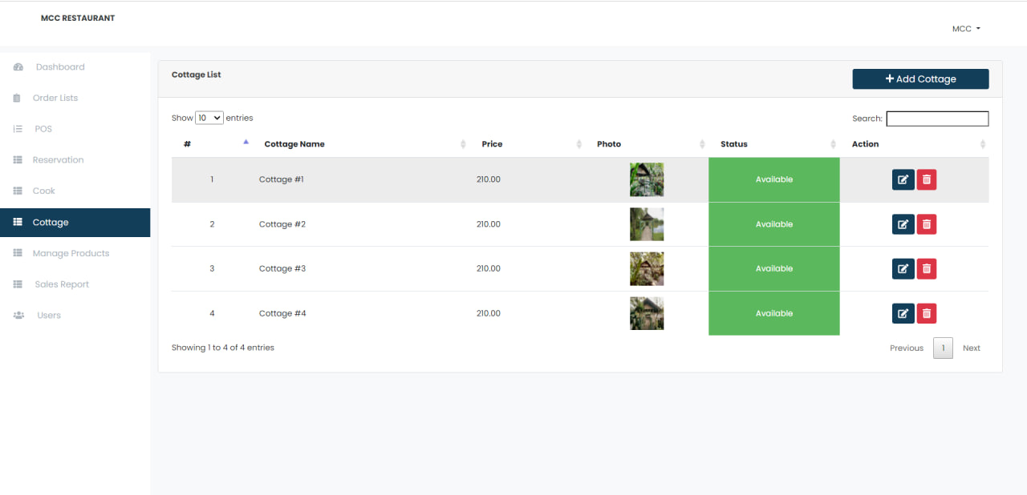

7

5

2

1

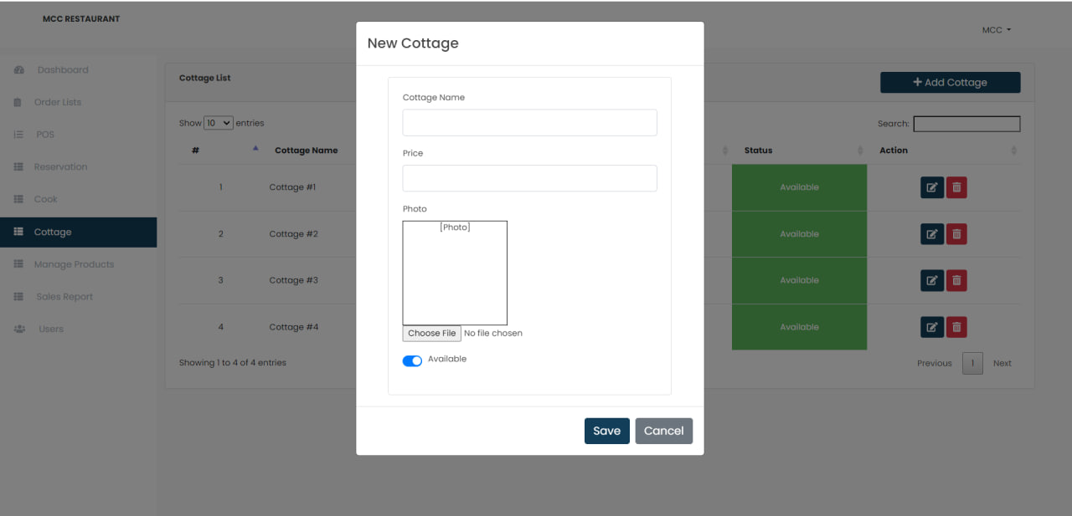

How To Add/Edit/Delete Cottage

Step 1: Click cottage

Step 2: Click add cottage

Step 3: Fill all the fields

Step 4: Click save

Step 5: Click edit icon

Step 6: Edit the field needs to edit

Step 7: Click save

Step 8: Click the delete icon

7

6

4

3

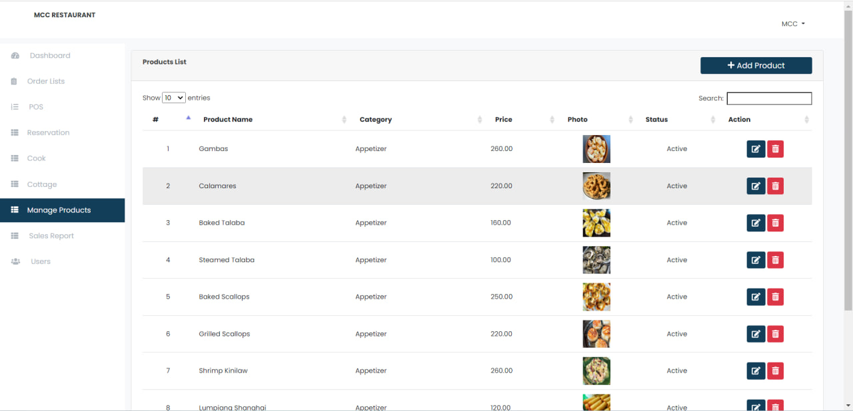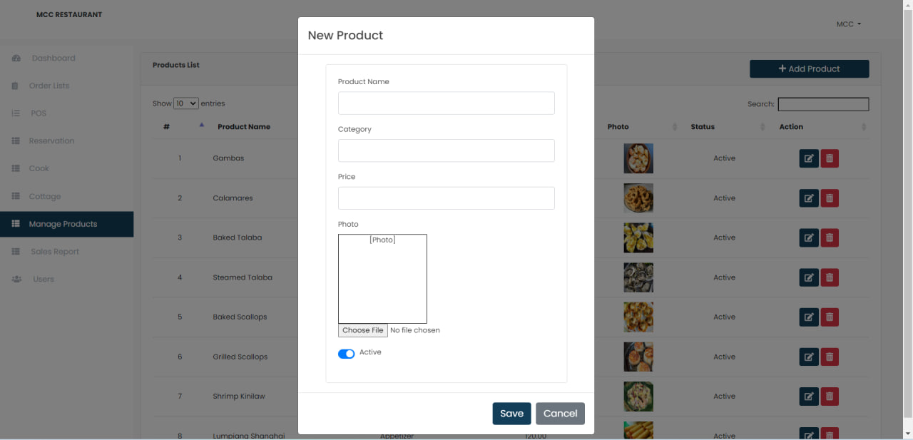

8

How To Add/Edit/Delete Products

Step 1: Click manage products

Step 2: Click add product

Step 3: Fill all the fields

Step 4: Click save

Step 5: Click edit icon

Step 6: Edit all the forms need to edit

Step 7: Click save

Step 8: Click delete icon

7

6

5

2

4

3

1



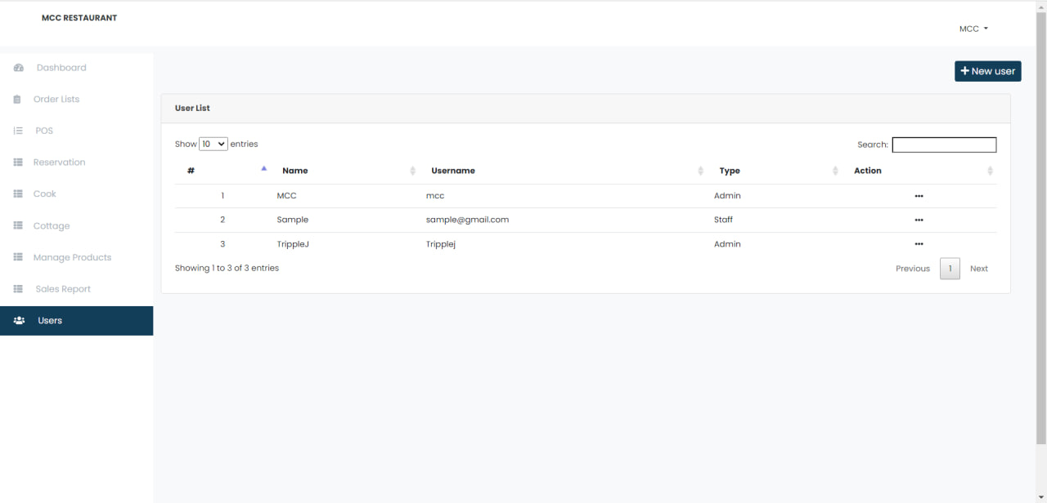

5

2

1

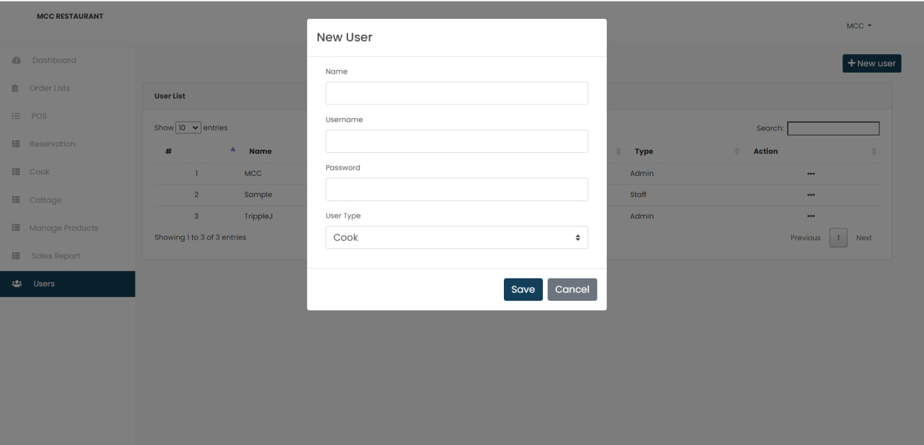

7

6

4

3

How To Manage Users

Step 1: Click users

Step 2: Click add users to add

Step 3: Fill all the field

Step 4: Click save

Step 5: Click the triple dot to edit

Step 6: Edit all the field

Step 7: Click save

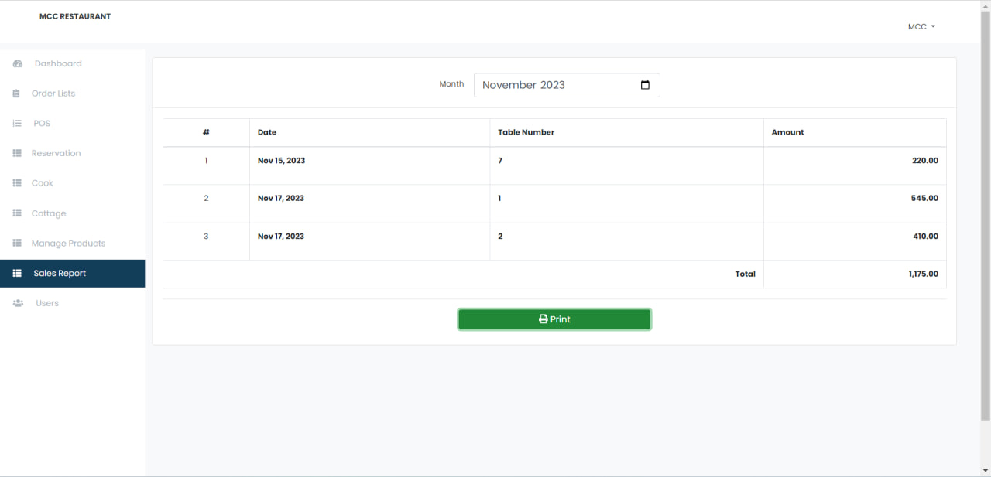

3

2

1

How To Generate Reports

Step 1: Click Sales Report

Step 2: Select Date

Step 3: Click Print

**Appendix F**

**Test Cases**

|  |  |  |  |  |  |
| --- | --- | --- | --- | --- | --- |
| Test Case No. | Test Scenario | Test Steps | Expected Result | Actual Result | Pass/Fail |
| 1. Log In account | Check if admin and staffs can log in on the system. | 1. Input credentials.  2. Click log in button. | Admin and staff can log in successfully. | Admin and staff are able to log in successfully. | Pass |
| 2. Add order details | Check if cashier is able to input orders | 1. Input order by selecting from dropdowns.  2. Click add order. | Cashier will be able to add orders. | Cashier successfully added a new order. | Pass |
| 3. Generate receipt | Check if cashier is able to generate receipt. | 1. Add order details.  2. Click add order.  3. Input payment details.  4. Click print receipt. | Cashier will be able to generate receipt with order summary. | Cashier is able to generate receipt with order summary. | Pass |
| 4. Scan QR code | Check if the customers can scan the QR code to enter ordering page. | 1. Scan QR through phone.  2. Click link to enter order page. | Customer will be able to enter the ordering page. | Customer successfully entered the order page. | Pass |
| 5. Add order details | Check if customers can add their order. | 1. Select from the choices on the order page.  2. Click add. | Customer will be able to submit their order. | Customer is able to submit their order. | Pass |
| 6. Add payment | Check if customer is able to add payment. | 1. Click order button.  2. Click Pay  3. Add payment details.  4. Click submit. | Customer should be able to submit payment. | Customer is able to successfully submit payment. | Pass |
| 7. Reserve cottage | Check if customer is able to reserve a cottage. | 1. Go to cottage page.  2. Click reserve button.  3. Input details needed on the form.  4. submit reservation. | Customer should be able to submit reservation. | Customer was able to successfully submit reservation. | Pass |
| 8. View virtual queue | Check if staff is able to view the virtual queue of order. | 1. Access dashboard.  2. View order | Staff should be able to view the orders. | Staff is able to successfully view the order on queue. | Pas |
| 9. Add menu items | Check if admin is able to add menu items. | 1. Access menu items dashboard.  2. Click add menu.  3. Add details on the form and click add. | Admin should be able to add menu items. | Admin as able to successfully add menu items. | Pass |
| 10. View summary of sales | Check if admin and staff is able to access the summary of sales. | 1. Click the designated sales button.  2. Sort according to data. | Admin should be able to see the summary of sales. | Admin is able to successfully access the summary of sales and filter the data. | Pass |
| 11. Modify reservation. | Check if admin or staff is able to modify reservations. | 1. Click on reservation button.  2. Click one reservation.  3. Modify or confirm reservation. | Admin or staff should be able to modify the reservation. | Admin and staff are able to modify and update the cottage reservation. | Pass |

**Appendix G**

**Compliance Sheet**

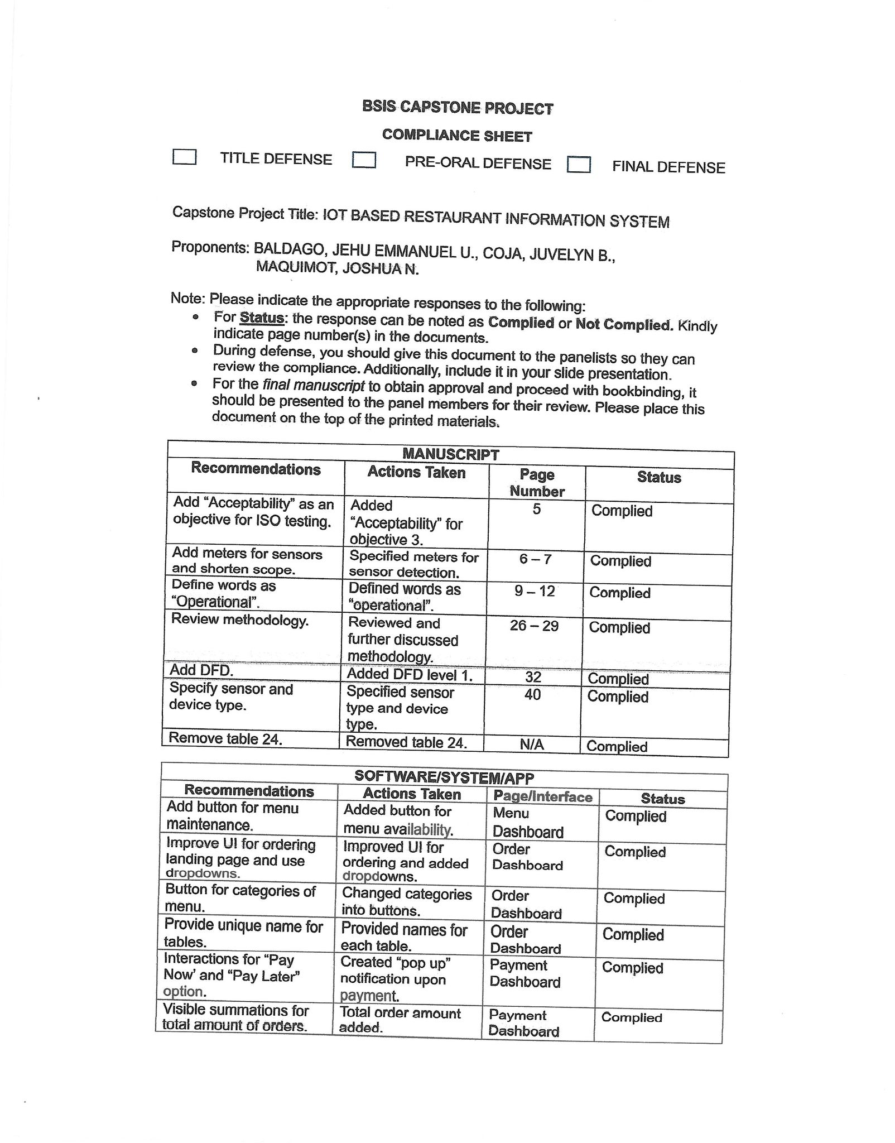

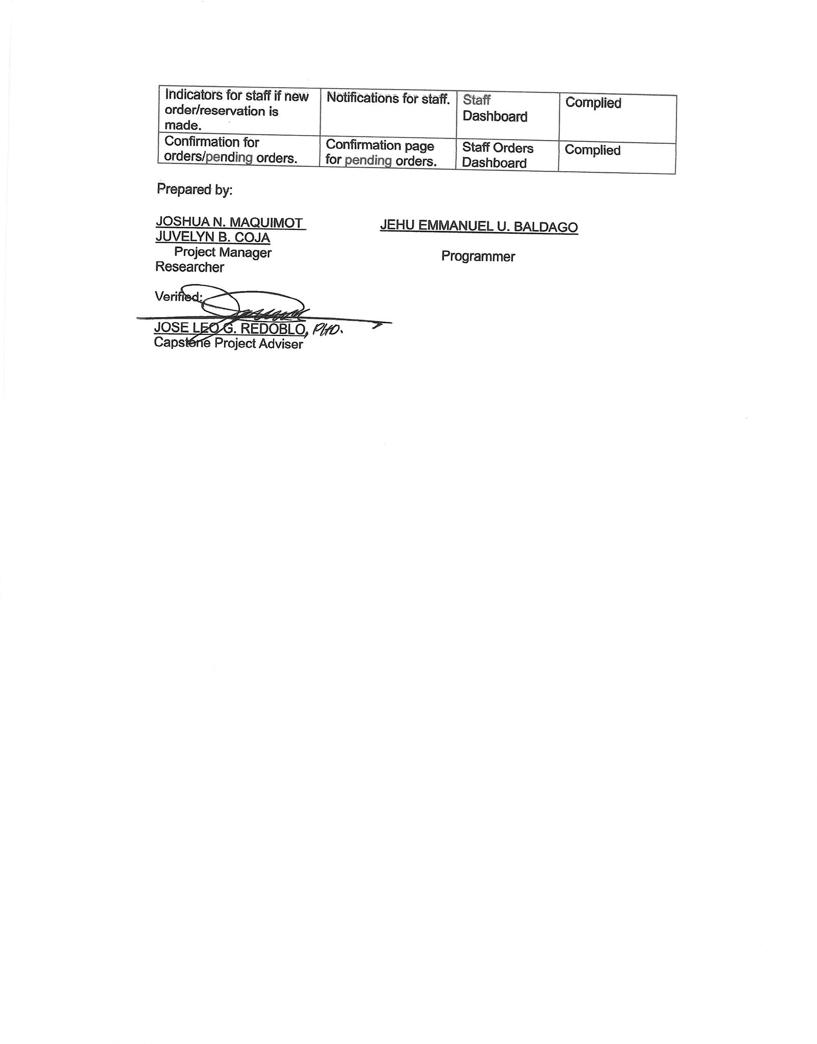

**Appendix H**

**Certification**

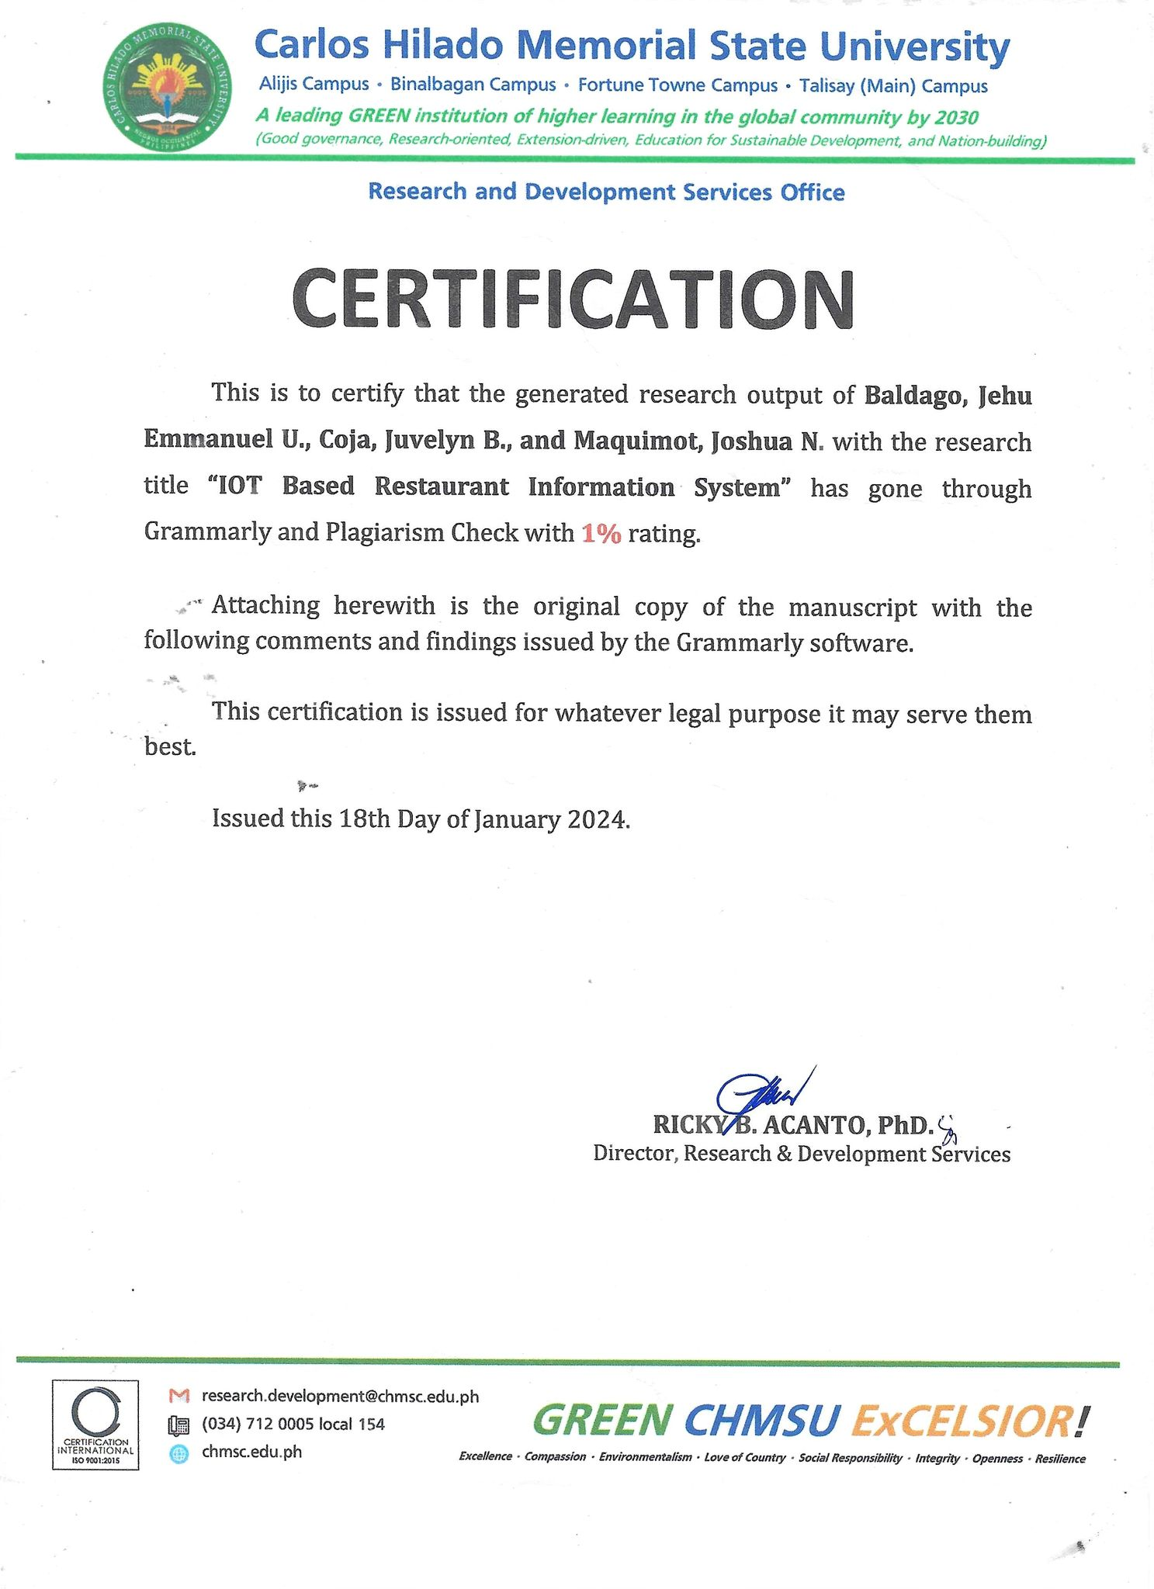

**Appendix I**

**Curriculum Vitae**



**JEHU EMMANUEL U. BALDAGO**

Adress: Brgy. Villamonte, Bacolod City

Contact Number: 09933108297

Email: jehu.baldago@gmail.com

**PERSONAL BACKGROUND**

Date of Birth: December 14,1999

Place of Birth: Bacolod City

Height: 5’1 ft.

Weight: 60 kgs.

Sex: M

Civil Status: Single

Religion: Baptist

Nationality: Filipino

**EDUCATIONAL BACKGROUND**

College: Carlos Hilado Memorial State University

Bachelor of Science in Information Systems

S.Y. 2020 - Present

High School: Negros Occidental High School

S.Y. 2018 – 2020

Alternative Learning School

S.Y. 2017 – 2018

Elementary: Asuncion Lizares Elementary School

S.Y. 2015 - 2017

**SEMINARS ATTENDED**

Synology Day 2023 – November 2023

**JUVELYN B. COJA**



Adress: Brgy. Balaring, Silay City

Contact Number: 09668656106

Email: jbcoja.chmsu@gmail.com

**PERSONAL BACKGROUND**

Date of Birth: August 24,2001

Place of Birth: Silay City

Height: 5’2 ft.

Weight: 48 kgs.

Sex: F

Civil Status: Single

Religion: Roman Catholic

Nationality: Filipino

**EDUCATIONAL BACKGROUND**

College: Carlos Hilado Memorial State University

Bachelor of Science in Information Systems

S.Y. 2020 - Present

High School: Silay Institute

S.Y. 2018 – 2020

Dona Montserrat Lopez Memorial High School

S.Y. 2014 - 2018

Elementary: Lantad Elementary School

S.Y. 2008 - 2014

**SEMINARS ATTENDED**

Synology Day 2023 – November 2023

**JOSHUA N. MAQUIMOT**

Adress: Brgy. V, Poblacion, Silay City

Contact Number: 09489960176

Email: jnmaquimot.chmsu@gmail.com

**PERSONAL BACKGROUND**

Date of Birth: August 10,2001

Place of Birth: Silay City

Height: 5’8 ft.

Weight: 60 kgs.

Sex: M

Civil Status: Single

Religion: Iglesia Ni Cristo

Nationality: Filipino

**EDUCATIONAL BACKGROUND**

College: Carlos Hilado Memorial State University

Bachelor of Science in Information Systems

S.Y. 2020 - Present

High School: Silay Institute

S.Y. 2018 - 2020

Elementary: Barangay Guimbala-on Elementary School

S.Y. 2009 - 2014

**SEMINARS ATTENDED**

Synology Day 2023 – November 2023